Fight, Win and Survive: Techniques, Tactics and Procedures for the Multi-Domain Battlefield

“The Army will definitely have to organize differently, probably into smaller, more compartmented groups. We will have to have, what I think, is a lot of relatively small formations that are networked and can leverage Air Force and naval-delivered joint fires. If you think of how some of our special operations operate today, that may be a preview of how large your Army operates in the future. That doesn’t mean you do away with battalions and brigades, but the fighting element will probably end up having to be a much smaller entity.”

-GEN Mark A. Milley on the character of future warfare.

199th Infantry Brigade,
Maneuver Center of Excellence,
Fort Benning, Georgia

Table of Contents

Acknowledgments 1
Preface 2
Russian New Generation Warfare: Setting the Stage 7
Innovation and Change: Nuances to the Modern Light Infantry 14
Limitations with the Current Structure 17
A More Lethal and Sustainable Structure 18
Tactics of the New Structure 21
Urban Reconnaissance Tips 29
Advanced Planning Considerations 33
Communication Tips 34
Leader Tips 38
Weapons Tips 39
LCE/Ruck Tips 43
Remain Overnight Tips AKA ORP Establishment 45
Breaking Out of Encirclement/Immediate Dispersion Tips 48
Movement Technique Tips 51
Infiltration/Exfiltration Tips 55
Reconnaissance Patrol Tips 57
Forward Air Controller (FAC) / Joint Fires Observer (JFO) Tips 62
Planning Considerations for Joint Fire Observers 66
Special Consideration to Enemy Drone Capabilities 68
Sustaining the Restructured Force 69
Scavenging as a Form of Sustainment 72
Training Tips While Not Deployed 73
Revitalizing the Infantry Schoolhouse 75
Appendix 1: References 78
Appendix 2: Coordination and Contingency Planning 80
Appendix 3: SOSRA For EW/Cypher 92

This Page Intentionally Left Blank
Acknowledgements

- COL Anthony Judge is the commander of the 199th Infantry Brigade and author of the foreword. He found the need to enhance small unit survivability on the multi-domain battlefield by taking lessons learned from Vietnam and adjusting them for the modern era.

- LTC James Zanella
- MAJ JB Blalock

- MAJ Adam Dortona currently serves as the Executive Officer for 2-11 Infantry and is the editor of the document and author of the preface.

- 2LT Charles Chandler is a Ranger, RSLC, JFO and Pathfinder qualified Infantry Lieutenant who will be moving to the 101st Airborne Division to serve his Platoon Leader time. 2LT Chandler personally authored ‘Urban Reconnaissance Tips,’ ‘Advanced Planning Considerations,’ ‘Sustaining the Restructured Force’ and ‘Communication Tips.’ He also developed the Revised Infantry Structure found on page 8, the autonomous movement diagram on page 9, and collaborated with 2LT Karber on ‘Forward Air Controller (FAC) / Joint Fires Observer (JFO) Tips.’

- 2LT John Karber is a Ranger, CDQC, RSLC and JFO qualified Infantry Lieutenant who, upon completion of his training at Fort Benning, will be moving to the 10th Mountain Division to serve his Platoon Leader time. 2LT Karber personally authored the chapters ‘Innovation and Change: Nuances to the Modern Light Infantry,’ ‘Limitations with the Current Structure,’ ‘A More Lethal Structure,’ ‘Forward Air Controller (FAC) / Joint Fires Observer (JFO) Tips,’ ‘Advanced Planning Considerations,’ and ‘Special Considerations to Enemy Drone Capabilities.’ 2LT Karber and Chandler collaborated to create the chapters ‘Training Tips While Not Deployed’ and ‘Revitalizing the Infantry Schoolhouse.’

- 2LT Scott Schwab is a Ranger and CDQC qualified Infantry Lieutenant who will be moving to the 10th Mountain Division to serve his Platoon Leader time. 2LT Schwab established the formatting of the document, specifically creating the ‘Table of Contents’ along with ‘Acknowledgements’ and ‘Appendix 1.’ 2LT Schwab was also used to read through the document as a non-RSLC or JFO graduate to ensure the material was transferrable to the average subordinate leader.

- Project (B-720) 1/7SFG, Combat Recon Manual, 1995.

- Project (B-52) Delta, Special Forces Combat Recon Manual.

PREFACE

Our aim with this paper is simple; we hope to help units fight, win, and survive on the battlefields of today against peer competitors in multi-domain operations. It is well understood that the U.S. military has a host of assets available that can deliver positive effects at the strategic level but how does this translate into success for the average Soldier in conventional brigade combat teams across the force? Our peer adversaries have been studying our every move for the better part of two decades. While we have focused on counterinsurgency they have been making solid gains in research and development. Specifically, with electronic and cyber warfare. Operations in eastern Europe and the South China Sea have shown us that our adversaries are willing to push the envelope in the competition phase to further their geo-political goals. Their objectives are predicated upon the assumption that we won’t risk all-out war to halt them, and it is working.

Russian New Generation Warfare
Studying Russian New Generation Warfare has yielded alarming results in our gaps in capability to compete for overmatch in every domain. Our measures remain largely reactive in nature to preserve combat power which is what this document aims to achieve in the short term. We want to provide techniques, tips, and procedures to the conventional force which have been previously reserved for reconnaissance or special operations forces. Every unit must be able to disperse in the face of an enemy that is willing to mass fires to destroy entire formations as evidenced in Ukraine. We also need to be able to bring our formations together at the decisive point when permissive conditions exist in at least three of the five domains. The tactical, operational, and strategic advantages we have enjoyed since the end of the Second World War are now a thing of the past and we must rely on exceptional initiative from commanders at all levels to develop unique solutions to battlefield problem sets. The game of checkers has now turned into chess and we need to expose the force to as many ‘moves’ as possible.

Risk
Risk will now be a staple in the American routine and something we must embrace during every phase of operations. Leaders who have grown accustomed to serving in a zero-defect force will have considerable trouble outsmarting an enemy that values human life far less than we do. Mitigation will continue to be of paramount importance to our battlefield repertoire. Risk aversion however will result in disaster. We must resist our temptation to micromanage every aspect of warfare and allow subordinate leaders to execute Mission Command. Understanding that the excessive radio transmissions you send to subordinate elements could result in the annihilation of the very force you’re trying to preserve. Our enemies mass fires to delete entire grid squares with robust indirect fire assets by calling for fire on simple signal transmissions. Our force has paid lip service to understanding, visualizing, describing, and directing for the past 17 years due to our embroilment in our seemingly endless counterinsurgency campaign. The potential impact of the ‘strategic private’ has caused us to keep many decisions close to the chest at every echelon of command for fear of losing the information operation battle. It is imperative that we take our lessons learned from Iraq and Afghanistan for what they are; situationally important but fail to translate into success during total war. If we aim to defeat the enemy decisively then our operations may need to look like what Robert E. Lee did at Chancellorsville in 1863. Splitting up his numerically inferior army into smaller elements tasked to execute bold attacks in keeping with the characteristics of the offense to rout a superior force. We hail battles like this in academia yet struggle to allow squads in an infantry platoon to operate unilaterally for any length of time. In the fight to come, it is the Staff Sergeant, not the General, who will be the primary instrument of victory. This paper will highlight proposed changes the Task, Organization, and Equipment of Squads in Brigade Combat Teams to make them more lethal than at any point in our 243-year history.

Deception
Deception is an artform that will be crucial in the fight to come and must be practiced at every level to throw off an enemy who has taken copious notes on how we do battle. Our reputation for veering from the very doctrine we aspire to master will continue to give us a competitive edge but only if we sharpen our skills. This goes far deeper than the example of Field Marshall Montgomery effectively juking Field Marshall Erwin Rommel during the Second Battle of El Alamein; causing him to commit his reserves elsewhere. While this may be a great example of mastering deception in the land domain, our forces in 2018 need to compete electronically, in the air, and in space. The enemy disruption zone now spans to our home shores. Using social media, cyber warfare, and real time tracking 24 hours a day, our adversaries aim to prevent us from building up combat power on their doorsteps like we have in the past. Once we are engaged in the fight, the need to creatively deploy our assets to throw the enemy on their back foot will be crucial. This paper aims to arm our Soldiers with some tips to use technology to deceive. What we need from the force are more in-depth measures to achieve this.

Changing the Rules of Warfare
The rules of warfare need to be revisited if we truly hope to gain traction during the competition phase with our adversaries. Are we willing to adapt and loosen our rules of engagement or will we continue to remain parochial in our attempt to be the good guys? Our military can continue to be the force which does battle with the armies of darkness and remain a force for good in the world. However, we can only achieve this if we are alive. If our enemies infiltrate areas with entire brigades in civilian clothing, then how do we compete? Insurgency and asymmetric warfare are in our blood, therefore it’s important we harness that to our fullest potential. When we took to the field on April 19th, 1775 during the Battle of Lexington and Concord we found out the hard way that going toe to toe with the British led to tactical disaster. Our ancestors then harassed their formation all the way back to Boston while inflicting heavy casualties by using unconventional tactics of the period. The British were frustrated that we refused to engage them honorably in open warfare; instead using cover being rock walls and trees to engage. Their inability to adapt to our methods led to their demise. We run the risk of repeating the same mistakes of the empire we gained our independence from. If America is going to continue to be the greatest force for good in the world then we must change the rules of the game that has defined us for the better part of a century. The only unfair fight is the one we lose.

Task Organizing Intelligently
Task organizing is both an art and science we have failed to master in our recent campaigns; mostly due to lack of resources and inability to accept risk. Our infantry formations remain largely unchanged since World War Two and this is not the case for our adversaries. A Russian commander can program different assets for an upcoming mission with relative ease. All while powering these combat multipliers to the lowest level. One of their squads in Ukraine can be up to 18 men in size and include cyber, air defense artillery, electronic warfare, drone, and enhanced fire support assets. Many of those capabilities in the U.S. military are reserved at the strategic level while our adversary enjoys them tactically. They will also drastically adjust load and uniform to meet operational needs. How many of you reading this remember suffering a casualty in Iraq or Afghanistan which prompted a blanket policy on the uniform within the battlespace? Instead of plate carriers or a more movement friendly uniform in general, the unit was forced to wear full IOTV with groin protector, deltoid axillary protector, and side small arms protective inserts. This obviously drastically reduced a Soldier’s ability to maneuver and decisions on uniform posture were often reserved at the brigade level or higher. Being weighed down by excessive amounts of gear will be a hinderance against a peer competitor that can mass effects on large portions of the battlespace. A react to indirect fire drill would be a sad sight to behold due to our inability to move quickly out of the kill zone. As you can see this is a recurring theme for this document. We must empower our subordinates in every way.

Snap Drills
Our execution of ‘snap drills’ is sorely lacking in our current training methodology. We have assumed for far too long that CTC rotations adequately prepare our forces to fight a conventional war with a peer. Adversaries conduct these last-minute exercises frequently which serve to create a more resilient and adaptable formation. Not to mention it also stresses the logistical systems in place to make such a maneuver possible. While we can execute these frequently within a Company formation at home station, it is another thing altogether to move a Battalion or Brigade from Fort Riley to Alaska with a seven-day turnaround. This is an extreme example but if we aim to keep our formations sharp then stressing them to this degree will be crucial. Such a change to our training methodology would also send a clear message to potential enemies that we will break the mold to overmatch them decisively at first contact.

Mobility Is Life
Russians maintain mobility in all formations which increases their effectiveness during operations. Every infantry unit has some sort of vehicular asset to move them across the field if needed. 3,000 years of warfare tells us that firepower equilibrium equals attritional warfare. Attempts to mitigate such effects lead to formations spreading out to absorb that firepower more effectively (think skirmisher formations in Napoleonic Warfare). Those widely dispersed elements are highly vulnerable to mobile assets and our adversaries balance these two battlefield doctrines well. One of our greatest under-utilized strengths lie in our mechanized formations which are in sore need of revitalization both technically and mentally. We need to reinvest in our mechanized formations and actively remove the stigma that light infantry is where our highest performers often end up. An increasing number of officers are snubbing the vehicular imperative and remaining in the light world for this very reason. These units are the most lethal on the field when the right leadership comes together to provide exceptional purpose, direction, and motivation. Our investment in understanding combined arms warfare at the lowest level possible will pay dividends in the wars to come since they are the mobile striking force needed to take advantage of dispersed enemy formations. This paper aims to show light forces how to remain alive, but our heavy formations need to be the big stick deterrent to our enemies.

Analog Imperative: Being Comfortable in the Fog of War
Until research and development catch up to our peers, we need to embrace the analog nature of warfare to reduce our signature on the field. We will be facing jammers, sensors, drones, and hackers. Our short-term Ace up the sleeve is our ability to go completely dark in the face of our enemy’s watchful eye. The Navy still executes similar drills with excellent results. We must train our units to operate without any emitting assets to preserve combat power until conditions are set to achieve overmatch in the electronic warfare domain. Tied to this is the need for proper simulation of enemy-caused degradation to our electronic capabilities during exercises. This paper contains several drills to ‘disappear’ on the field of battle.

Communication of Emerging Doctrine Internal to the Force
Second Lieutenants were tasked to provide several inputs to this document for specific reasons. They are recent Infantry Basic Officer Leader, Ranger, Reconnaissance and Surveillance Leader, Joint Fires Observer, Airborne, and Pathfinder course graduates. Equipping them with Russian New Generation Warfare strategic context and other problems we face by peer adversaries, we sent them off to all this additional schooling to see if there were answers to the problem we face organic to our force. What we discovered was that our solutions to tactical, operational, and possibly strategic problem sets largely exist in schools on Fort Benning alone. Many entities are working on outstanding outputs but are doing so in vacuums. General Milley has expressed frustration that our main problem is we don’t communicate with one another. Putting together these lessons learned has shown us that we need to actively reach out to organizations, send Soldiers to schools, talk to proven professionals, and unite them under a common flag for maximum efficiency. Bridging the gap between several subject matter experts on this base alone has created outstanding opportunity.

Roadblocks to Doctrinal Creativity
It’s important that we as leaders understand the difference between what is urgent and important. Winning the first battle of the next war should be first and foremost on the mind of every Soldier in the formation. Fostering command climates which reward creativity and create permissive environments for revolutionary thought will have advantages on the field. Often times we get caught up in day to day minutiae because our organizations tend to prioritize administrative tasks. These often become urgent in our eyes and can consume most hours of the day for even the most efficient among us. Establishing a solid battle rhythm and delegating tasks accordingly is crucial to freeing up time for leaders to execute the critical thinking necessary to win future wars; this is important work.
Fort Benning went through a significant revolution during the interwar period led by legendary leaders George C. Marshall and Omar Bradley. They were forward thinkers who rebuilt our doctrine from the ground up based on their assessment of what future wars would look like. Our performance during the Second World War would have been far worse if we used tactics from 1918. The study executed by DG Don Starry during the 1970s-80s led to the establishment of Air Land Battle doctrine. The result of which led to our overwhelming the Iraqi army during the Gulf War.
The common denominator between the aforementioned examples is that those students of war had the opportunity to sit back and watch other countries fight far away wars while they took notes. We find ourselves in a similar situation with Eastern Europe and the South China Sea. The lessons we need to learn are right in front of us. We need only create the time and environment to facilitate such thinking.

Russian New Generation Warfare: Setting the Stage
In order for the proposals this document aims to address to be fully understood, the following slideshow assesses the problems that the United States Infantry will face when a peer threat is engaged.

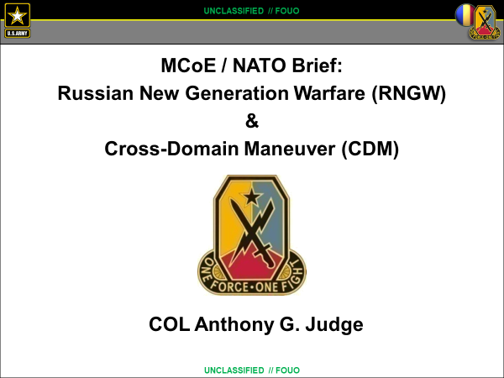

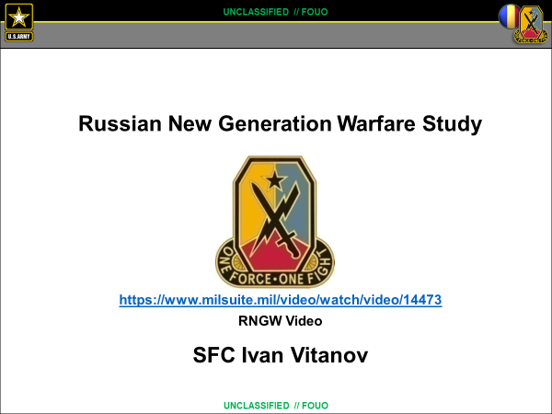
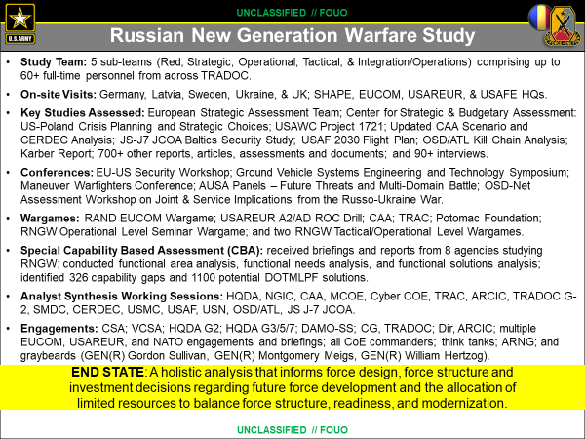

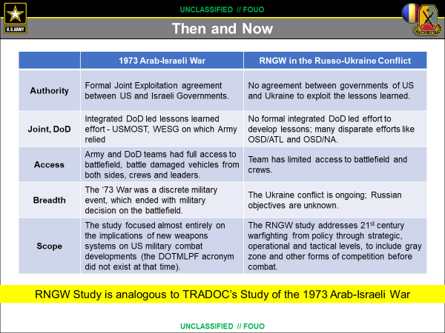

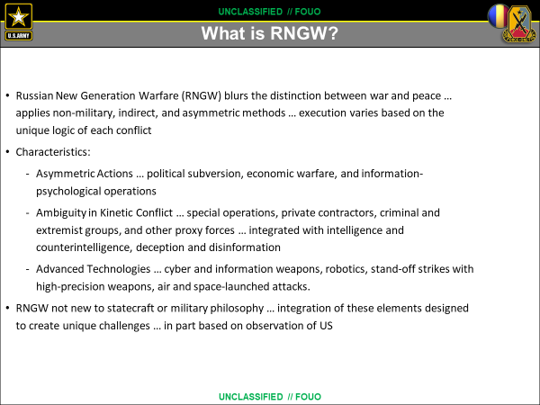

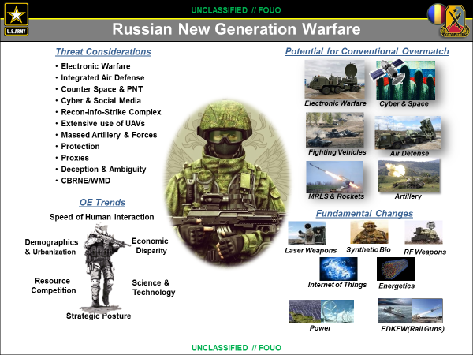

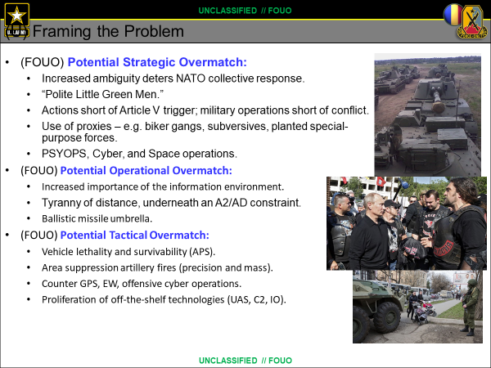

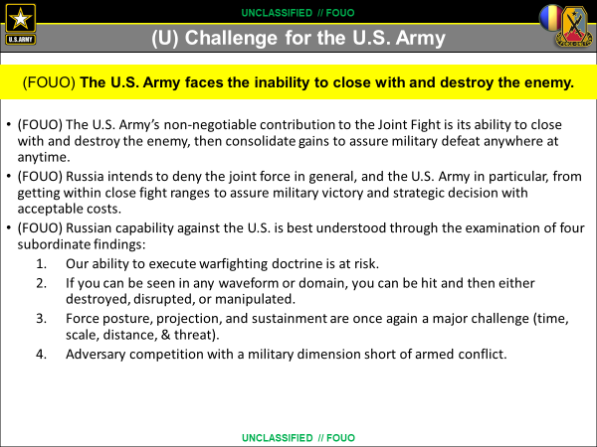

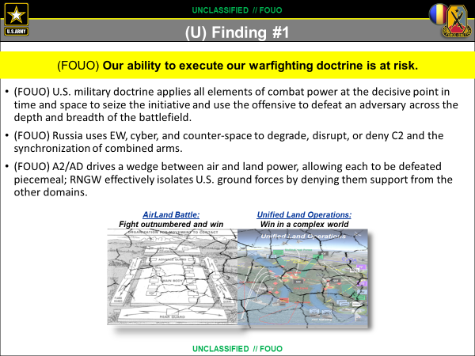

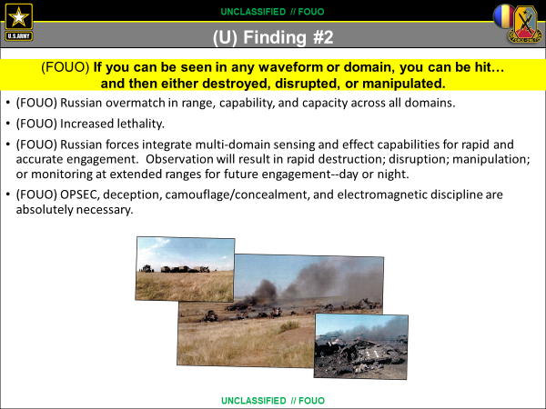

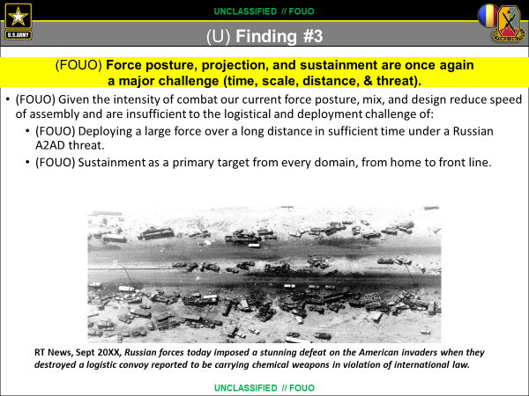

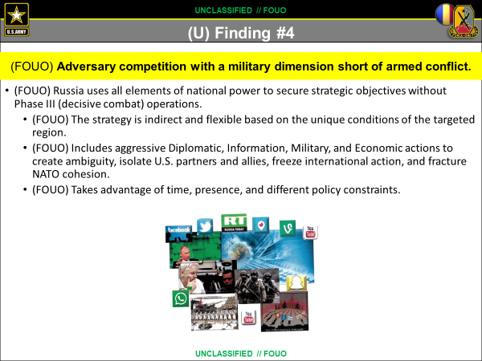

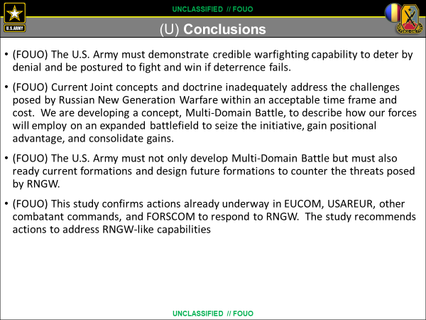

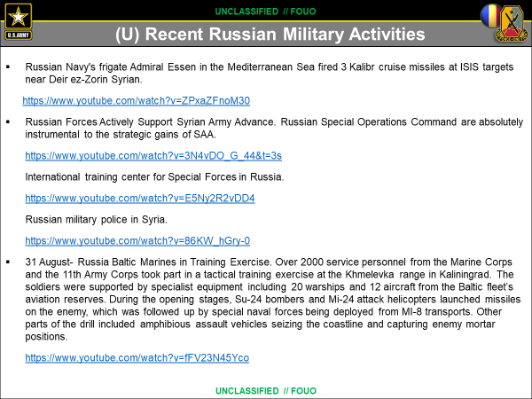

Innovation and Change: Nuances to the Modern Light Infantry
In order to maintain a competitive military force against recent examples of Russian military aggression, the most basic elements of our Army must be ready to undergo change to ensure a high level of lethality when called upon to defend our nation's interests. At the basic infantry platoon level, there is a need for greater reliance on Junior Officers and Non-Commissioned Officers to complete their given commander's intent without constant oversight or guidance. In order to do this, the large-scale footprint of American support and intervention must be drawn back, and leaders forced to do more with less. The days of placing TGI Fridays in Forward Operating Bases in other countries is over, and the future of radio silence and low electronic signature is around the corner. The Battle of Zelenopillya proves two mechanized Ukrainian battalions can be destroyed in a matter of minutes due to unsecured cell phone use, as seen in Figure 1. The United States must recognize and restructure to modernize and protect its forces.
With this restructuring in mind, it is important to address the issue of mission command and trust between company commanders and their junior level leaders. The constant flow of information to the commander must be limited. The use of communication devices increases the risk of interception and subsequent counter operations by Russian forces. Therefore, an in-depth planning process will facilitate an increased level of trust between the commander and his junior officers. Not only will the platoon leaders better understand the mission and the commander’s intent, they will also be able to conduct missions without substantial oversight. Designated communication windows will allow the commander to battle track with minimal exposure to Russian EW capabilities.
These new Infantry Platoons will conduct operations in conjunction with LRS units. These LRS units will provide the Infantry Platoon Leader with information on where the enemy is, how they are arrayed and where they may be struck to maximize damage.
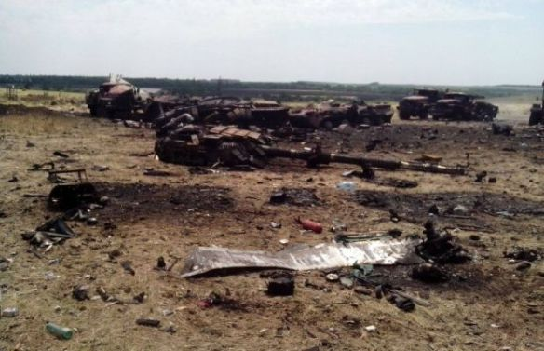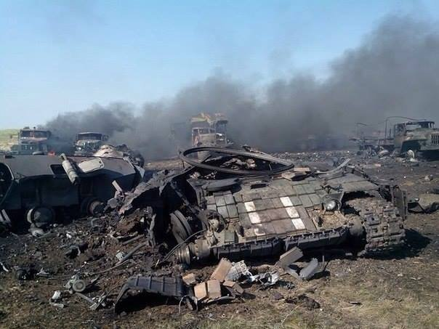
(Figure 1: Russian MLRS System destroys Ukrainian Army Forces July 2014)
Techniques and procedures by the United States military over the last fifteen years of the Global War on Terror will face greater disruption from comparable Russian electronic warfare platforms. GeoSpatial Mapping technologies such as LiDAR used by Special Operation Forces to understand buildings and layouts throughout Afghanistan and Iraq will stand greater chances of being intercepted or interrupted. A limit on the timeliness and accuracy of American intelligence of the battlespace is inevitable once other nations are able to interrupt any section of the multidomain interface of the current forces.
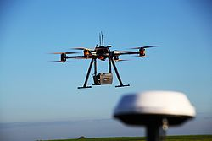
(Figure 2: US Multicopter UAV utilizing LiDAR for GeoSpatial Mapping)
Russian jamming capabilities can lock onto American communications and have effects that will limit the outcome of what each ground force commanders is able to achieve in their given battle space. Advance Forward Looking Infrared (ATFLIR) and SNIPER advanced targeting PODS on current UAS and CAS systems stand the same chances of being interfered with by Russian electronic warfare assets, as seen in Figure 2 and 3. Recent military operations throughout Iraq and Afghanistan have proved these means to be our primary methods of engagement. Recognizing the over reliance on electronic systems in our current force, the US can refocus on analog methods to achieve the mission without exposing US assets to Russian capabilities.
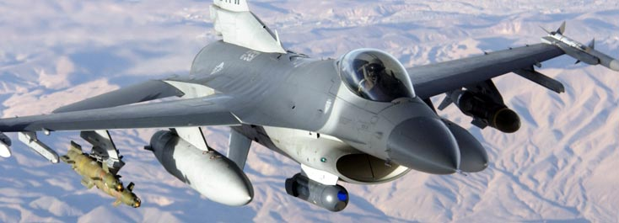
(Figure 3: F-16 with LITENING POD capabilities)
These capabilities like many others in the United States military arsenal are susceptible to Russian interference in the case of war. In order to revitalize the lethality of our fighting force, an in-depth knowledge of the analog methods that US fighting evolved from is paramount to ensure the success in future conflicts. In this document we bring together common-sense principles that have been earned through years of patrolling in a multitude of complex environments that can be applied to everyday training and operations.

(Figure 4: This is an overview of current systems emplaced to relay Target Information, and can easily be interfered with by Russian electronic warfare capabilities.)

Recommendation: Commanders begin to integrate analog methods of tracking, maneuvering, detecting, and operating in order to mitigate their digital signature. Adversarial capabilities have proven their ability to mass effects on units that rely upon a multitude of communication assets, as seen above in Figure 4.
Limitations with the Current Structure
d
A regular Line Infantry Platoon preparing for an operation in another country will currently have 35-40 personnel. With this size element, the electronic signature, and the overall footprint that a platoon will leave in an operational environment makes them highly susceptible to Russian targeting capabilities.

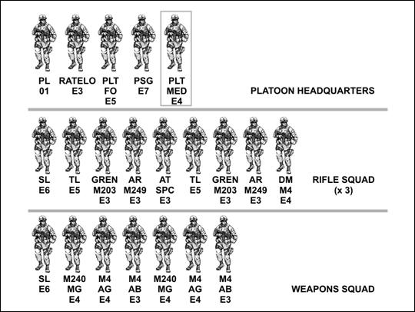

The overall dispersion radius of this size element from point man to trail man could expand 400 meters of terrain or more. Our adversaries can easily detect a formation of that size maneuvering within their restrictive maneuver boxes and utilize fires to decimate that formation. By reducing the size, but increasing the lethality and sustainability of the light infantry platoon, platoon leaders can operate more autonomously and with more control as they maneuver through time and space.

A More Lethal and Sustainable Structure
Proposed Platoon Restructuring
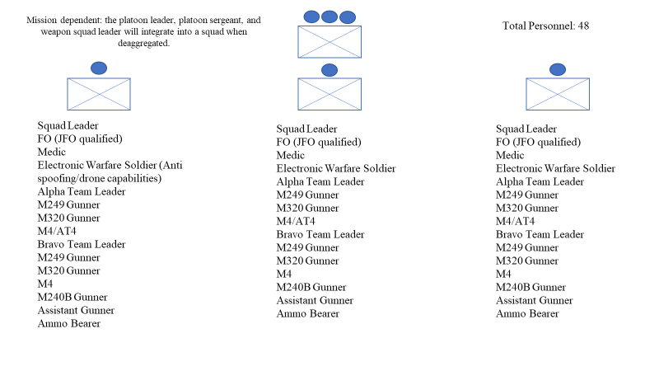
- Integrating a gun team per squad will allow for more effects when trying to disperse, maneuver, and close with the enemy. Integrating at least one electronic warfare Soldier per squad into this new formation will allow for leaders to better utilize UAS systems, counter enemy UAS, decrease their digital signature, and increase the tactical level of the cyber domain at the platoon level. Additionally, these EW Soldiers will provide counter IED capabilities.
  - Counter target acquisition must occur within twenty minutes at most. Russian tactics include using UAS/snipers to find and fix enemies, then finish via adjusting their fires from artillery and utilizing a BTG to maneuver after the artillery ceases.
  - The integration of a EW Soldier at the platoon level will increase the readiness of platoons to react accordingly when targeted, spoofed, or counter-tracked.

- The Marine Corps is attempting to incorporate a JFO qualified Marine into each of their squads. If the Army was able to coordinate the same, then ground force commanders would have the ability to dominate multiple domains simultaneously due to the effects a JFO can bring to the battlespace.
  - One key is the inability for JFO’s to give weapons release authority, meaning there is a dual requirement of having either a JTAC or FAC(A) present.
  - It is recommended that higher echelon leaders evaluate the possibility of granting JFO’s weapon release authority.

- The addition of an assistant RTO (ARTO) allows for increased communication capability such as understanding radio wave propagation, antenna theory, communication windows, and establishing communication in denied areas deep in enemy territory.

- The Platoon Leader is able to operate on the notion of having conducted detailed troop leading procedures, an extensive terrain and hydrology analysis, and a full contingency and coordination check. This will enable commanders to trust and enforce disciplined initiative from mission orders that provide detailed and specific commander’s intent.

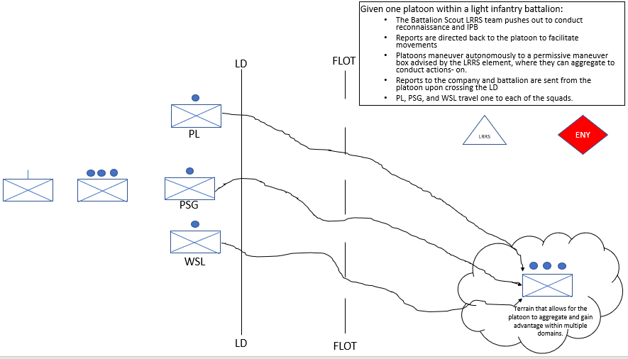

In the example above, the proposed changes to the light infantry platoon allow for the platoon leader to entrust subordinate leaders to operate autonomously during the movement to an area that presents a permissive maneuver area. The Battalion scout platoon is pushed well ahead of the battalion and is operating in efforts to continuously update IPB, answer PIR, and provide pertinent information to the platoon leadership.
The scout and conventional line platoon should operate in tandem with each other. The Battalion will need to establish communication windows, periods of zero digital signature, and utilize brevity terms. This information can be transmitted much easier to the Battalion command from the platoon due to the proximity and decreased chance of enemy interference. In order to act on accurate and timely information, the scout platoon should report to the platoons and then allow the platoons to communicate with Battalion.
An example operation would occur in the following manner: Battalion mission planning is conducted on all levels from Battalion command to fire-teams to ensure the complete mission order is understood. The scout platoon is pushed forward and establishes numerous surveillance sites, reporting information to answer PIR and paint the operational picture. Antennas and communication assets are used only during pre-planned communication windows with uni-directional antennas. The information is directed to the conventional line platoons, who then initiate movement in a de-aggregated manner to mitigate exposure and digital signature. The light infantry platoon operates in three squads as they maneuver to a more permissive location that provides an advantage in at least three out of the five domains of warfare. Additionally, the Battalion scout teams will direct platoons to maneuver where conditions are more favorable and conducive for offensive operations for the Battalion to stay mobilized and continuously gain terrain. Moreover, the Battalion TOC and logistical services maintain a mobile posture to maintain the tempo and capability to quickly maneuver.

Tactics of the New Structure

The following procedures must be executed by each Infantry Squad to de-aggregate and travel on their own to an objective and/or permissive maneuver box and area of terrain. These principals are built for a reconnaissance squad but will still apply for any smaller element traveling past the forward line of troops or FLOT. Principles and tactics utilized in the Reconnaissance and Surveillance Leader Course (RSLC) are inherently vital to the survivability and lethality of the autonomously maneuvering light infantry squads as they cross the line of departure and aggregate in a location close to their objective to conduct platoon level operations.

The following battle drills are primed to aid and assist with the restructured infantry platoon squad level operations. These battle drills are from the RSLC manual and provide enough flexibility for units to expand upon for their own standard operating procedures. Tactics such as actions at the ORP, formation and order of movement, linear danger areas, small open danger areas, break contact, and load plans are presented in the following pages of this document.

1. When coming to an area in which the element will reconsolidate and reorganize itself, the following diagram shows how ensuring the surrounding areas are clear of enemy presence:

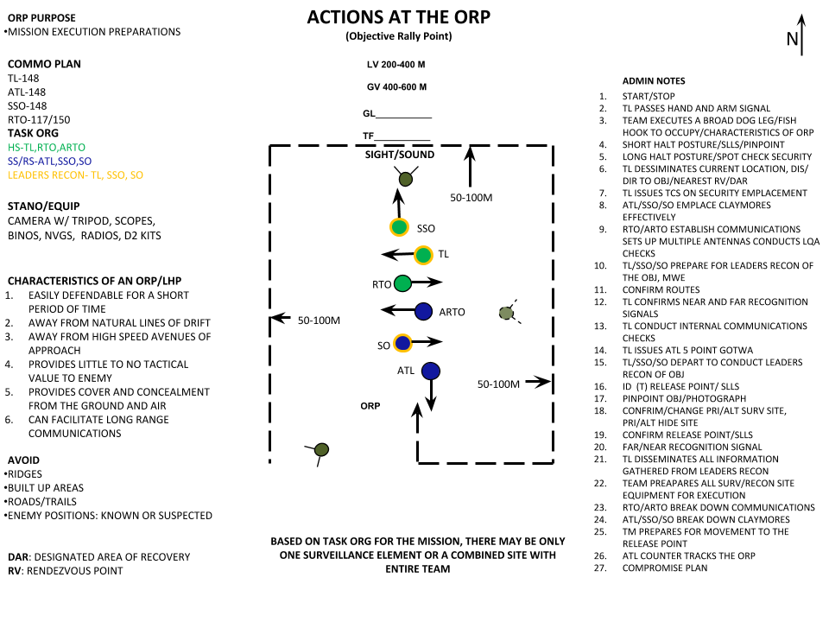
2. When performing SLLS the following methods can be used by the Infantry Squad or Reconnaissance Team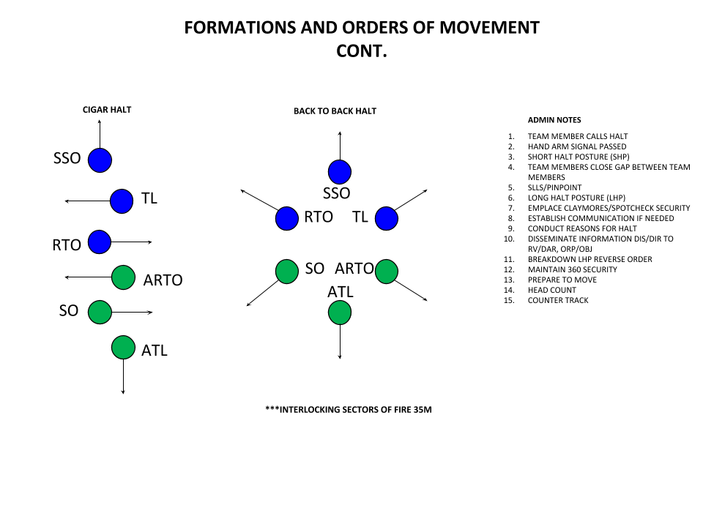

3. When crossing Linear Danger Areas as an element:
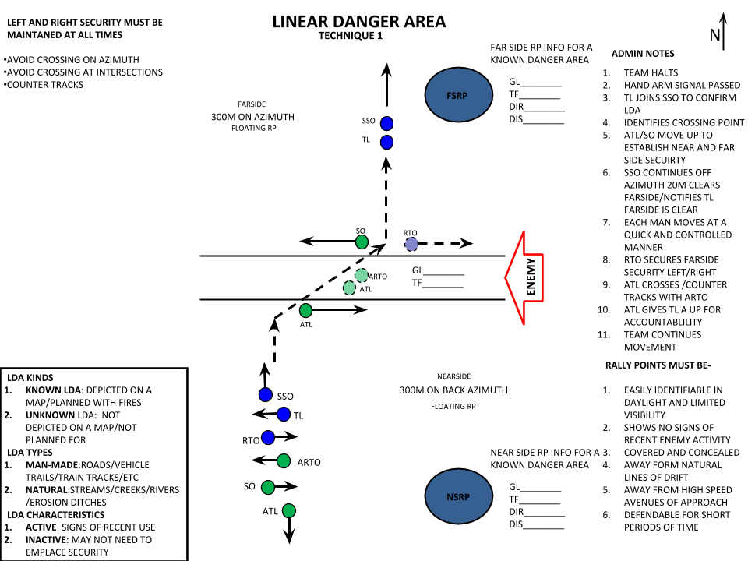

- When an element is bypassing a Small Open Danger Area:

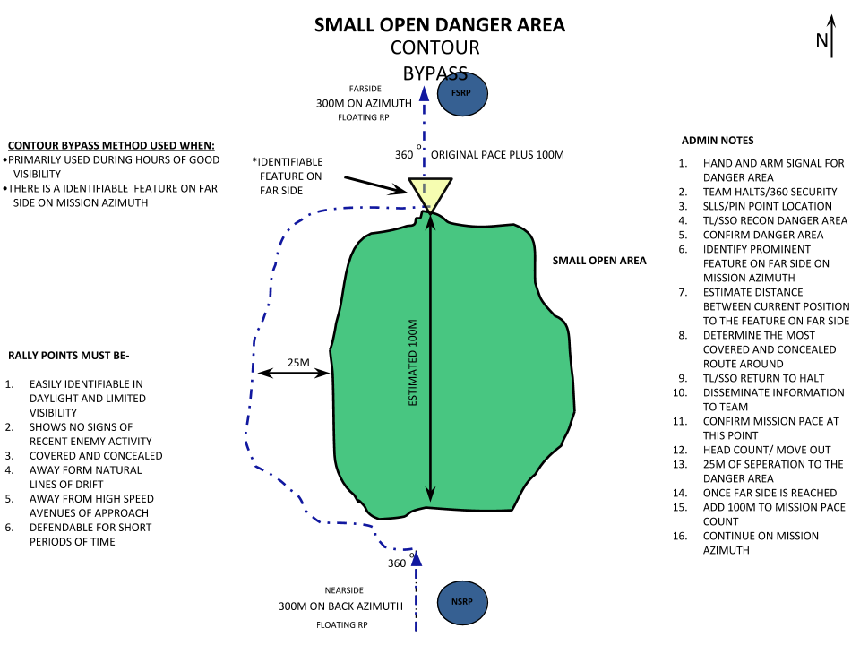

When a larger enemy force engages the Infantry Squad or Reconnaissance Team:
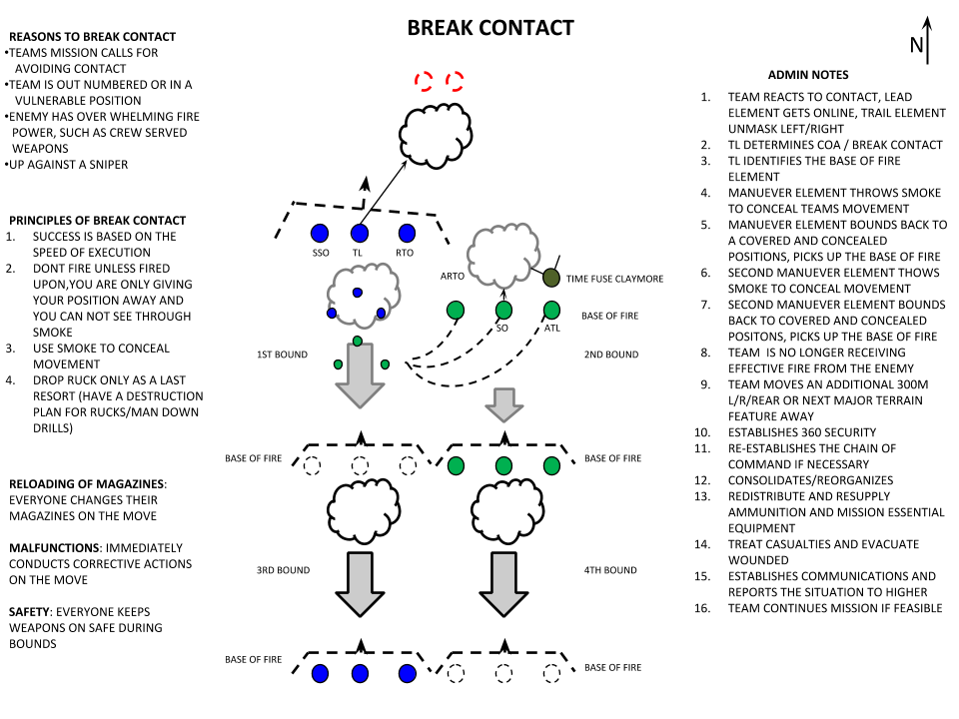

When the Infantry Squad or Reconnaissance Team is using a vehicle infiltration and is dismounting:

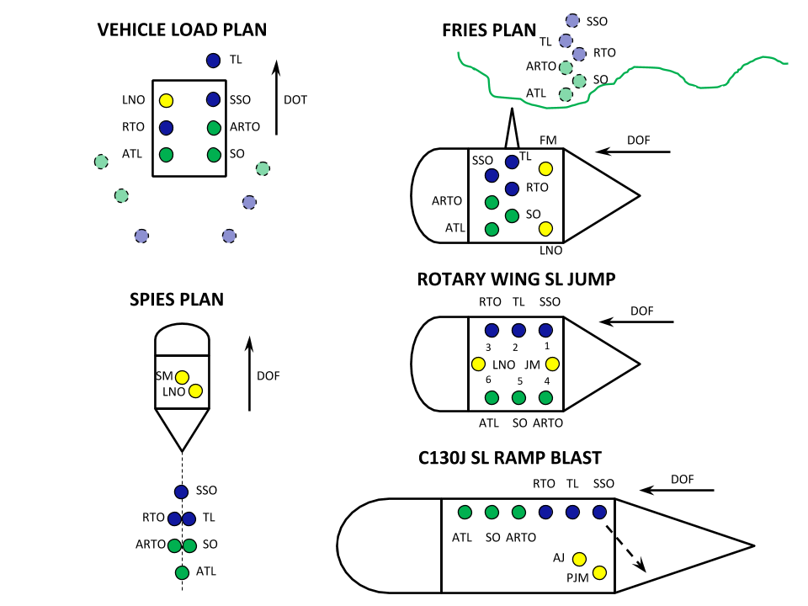

- Only a Reconnaissance element should employ a subsurface surveillance site due to the size of the element that will occupy:
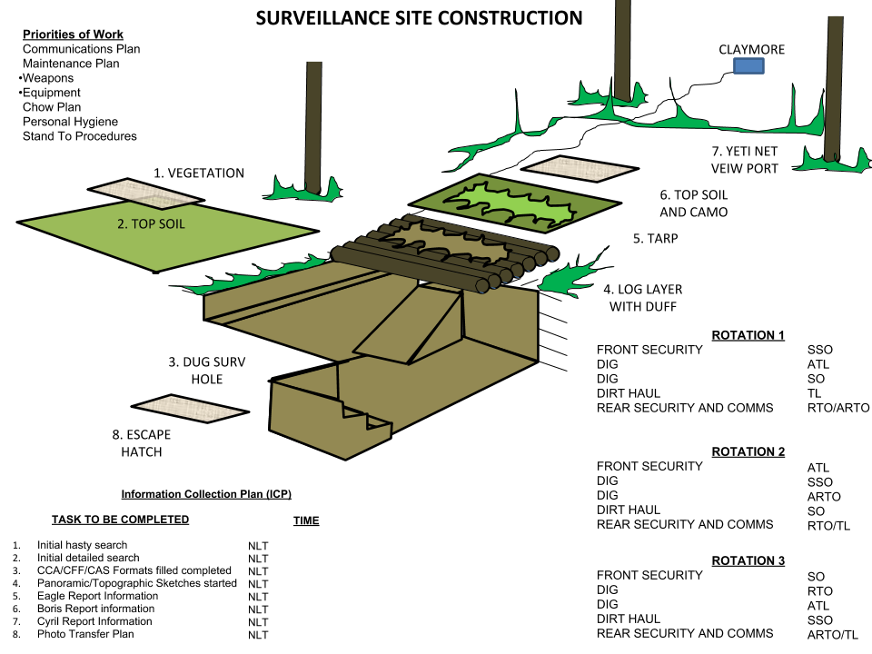

Urban Reconnaissance Tips

“A 2016 United Nations report estimated 54.5 percent of the world's population lived in urban areas. By 2030, that percentage is projected to rise to 60 percent. As a result of this rural-to-urban migration, cities themselves are growing. In 2016, there were 512 cities with at least one million inhabitant globally. By 2030, a projected 662 cities will have at least one million residents”- Maj. John Spencer, Deputy Director of the Modern War Institute.

- The nature of Urban Reconnaissance is inherently different. Close Target Reconnaissance (CTR) is a highly employed method in an Urban environment and must be planned for when determining how you will observe the enemy.

- Things to keep in mind while planning:
  - When conducting Urban Reconnaissance, a vehicle is almost always required, preferably one that does not expose equipment, number of personnel, or any sort of distinctive features of the patrol going out. If the team is forced to move in the urban terrain, they should use the interior of buildings and subterranean routes before traveling down streets in the open.
  - Considerations for Urban Movement should include:
    - Crossing Open Areas should be avoided
    - Natural kill zones are created in streets

- When moving inside of buildings, always avoid silhouetting yourself from doors or windows. Stay away from walls and avoid moving alone. When initially entering a building, dominate the room you are currently occupying by eliminating any threats, controlling any other occupants, limiting your verbal communication with your team, and finally searching the premise for additional information of value.

4. Risks of being compromised by residents of the building being occupied is constant, and should be discussed throughout the different phases of the operation during the planning process. This should include:
- What to do if there are personnel in the building we aim to occupy once we enter?
- How many personnel are current inhabitants there?
- Who might be expecting these personnel if we are to hold them while occupying?
- Is this building able to be accessed by other buildings, or is it a power or control hub for other buildings in the area?
- How often are people likely to travel through the surrounding areas, and area they likely to notice changes in this specific building?
- What is this building located in proximity of?
- How can we gain access to this building?
- What will we have to take in order to prevent others from being able to enter this building?
- What is the floor layout of this building, and where are its observation points located?
- Where in this building are we going to be able to set up a surveillance room, a commo room, a sleep room, and security measures?
- What other elements or units are likely to operate in the NAI during the length of the occupation?
- Does this building have a unobstructed line of sight into the targeted area of interest that can also provide concealment from anyone passing by?
- How will the team conduct a hard compromise blowout drill in the urban environment?

All these questions need to be answered before a team is ready to enter a building.

Example Layout of an Urban Site
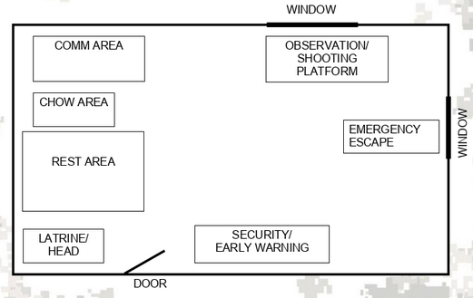

6. Stay Behind Operations are divided into two types: Unplanned and Deliberate
- An unplanned stay-behind operation is one in which a unit finds itself cut off from other friendly elements for an indefinite time without specific planning or targets and must rely on its organic assets.
- A deliberate stay-behind operation is one in which a unit plans to operate in an enemy-controlled area as a separate and cohesive element for a certain amount of time or until a specified event occurs. This type of operation requires extensive planning. The reconnaissance platoon and sections normally conduct planned stay-behind operations as part of larger units.

7. Dismounted movement in urban terrain should be avoided if possible. Use covered and concealed routes on the outskirts of the urban area. When the team is forced to move in urban terrain they should use the interior of buildings and subterranean routes when possible.

8. Outside Building movement considerations:
- Overwatch method
- Move parallel to building
- Maintain separation from wall
- Stay in the shadows/maintain low silhouette
- Maintain separation

9. Movement Inside of Buildings
- Avoid silhouetting from doors and windows
- Hallways
    - Avoid moving alone
    - Minimize exposure
c. Stay away from walls
    - Ricochets
    - Compromise

10. Remember, the element is vulnerable and may not have good situational awareness immediately upon occupation of an urban hide site. It is essential that the team maintains noise, light and movement discipline throughout the occupation process (SLLS). The site remains tentative until security and commo is established. The team must be prepared to vacate the site at a moment’s notice and not become complacent. Most important, maintain a Combat Mindset.

11. Five requirements when moving in an urban environment:
- Maintain 360 Degree Security
- Maintain Buddy Team Integrity
- Communicate
- Use NVG’s
- Maintain Combat Mindset
12. Building / Room Clearing
- Hold and Clear Technique
- Hold and Bypass Technique

13. Initial Bldg / Room Entry
- Dominate
- Eliminate
- Control
- Communicate
- Search

14. Windows
- Avoid bottom/basement windows if possible
- Stay below the window level and near the building
- Jump past the window without exposing the legs

15. Corners
- Observe before moving (below height expected)
- Masking of weapon (common mistake)
- Pie method (used when speed is required)

16. Walls
- Recon/Secure opposite side of wall
- Roll over wall (keep low silhouette)
- Speed of movement and a low silhouette will deny the enemy a good target

17. Crossing Open Areas
- Open areas should be avoided
- Natural kill zones
- Cross using bounding overwatch technique
- Use of smoke for concealment
- Recon shortest route and next position before moving

18. Examples of construction tools to enhance camouflage capabilities
- Watch, Handsaws/ Can saw, Wire cutters, Duct Tape, Cobra heads, Copper Wire
- Pry Bar, Mesh netting
- Hand Picks, Entrenchment tools, Pruning Shears

Advanced Planning Considerations

Imagine you are a member of an Infantry Platoon operating in Northern Ukraine. Three days of walking through rugged terrain has left you tired and mentally unprepared to determine your next action on the ground. If not for the luxury of your global positioning system you would have no idea where you are. As you begin your next movement, your DAGR reports a grid location that you have not previously anticipated along your route and without a baseline signal strength reading you have no idea your being jammed. Instead of checking it with your surrounding terrain and resectioning your location, you simply trust your technology and resume your planning off what your current Grid reads. You have now been directly sabotaged by a Russian Electronic Warfare asset in the area that will lead you into a kilometer wide kill-zone.

Until Inertial Navigation Systems (INS) are fully operational within the U.S. Army, preparing for manual and analog methods of conducting operations is vital for forces to maintain lethality. Land navigation being interfered with would have serious impacts on the implementation of graphical control measures. Leaving ground units unable to implement phase lines, boundaries, or restricted fire lines (RFLs) presents serious risks. For commanders it will lead to the inability to battle track units from command posts. In order to mitigate these risks, training and restructuring how our forces approach these threats must occur during the planning process.

Additional planning considerations are outlined in Appendix 2 for coordination and contingency planning.

Communication Tips

- Communications is one of the most important aspects of any operation. You can have an undetected insertion, gather critical intelligence, but if you are unable to transmit that intelligence back to your higher headquarters, you are nothing more than a liability to your commander.

2. Two types of communication that Soldiers must be subject matter experts in:
- Line of sight communications (LOS)
- Beyond line of sight communications (BLOS)

3. Line of sight communication refers to how radio waves travel from the transmit antenna to the receive antenna, limited by the visible horizon, due to the curvature of the earth.
- Due to the curvature of the earth an antenna that is 6 feet (2 meters) tall will transmit 5.0km.
- LOS ANTENNA FORMULA:
Distance in km = square root of (12.7 x Am)
( Am = the height of the antenna in meters)
c. If either the transmitting or receiving antenna is elevated another 6 feet, the transmission range will theoretically double.

4. Radio communication range is greatly influenced by three factors:
1) Frequency of operation
2) Radio output power
3) Antenna height

5. Increasing antenna height and radio output power are two factors that the user has control over.

6. LOS Radios:
- ASIP: Single band radio
- MBITR or AN/PC-148 radio: It is a multiband radio that has the capability to talk BLOS by utilizing satellites, ground based relays and RETRANS
- AN/ PRC-152: It is a multiband radio that has the capability to talk BLOS by utilizing satellites, ground based relays and RETRANS

7. Beyond line of sight communications is communication that extends past the visible horizon. And can include the possibility of communicating around the world with a single transmission.

8. Two types of BLOS
- Satellite
AN/PRC-117F, AN/PRC-117G
2) High Frequency
AN/PRC-150

9. Before you leave for a mission you should always:
- Know the locations (grid) to whom you are reporting to and friendly units in your area of operation (AO).
- Conduct a COMMEX with the base station and other units in your AO.
- Have enough batteries to conduct your mission plus one additional day.
- Know the frequencies and locations of supporting units (MEDEVAC, Link-up, CAS, and Artillery).
- Know when COMSEC roll times are and the days they occur.
- Have a primary, secondary, and if possible a tertiary form of communication. (Iridium / Thuraya satellite phones)
- Understand the Terrain and how it will effect communications when you plan your ORP, HS/SS, etc. (don’t be afraid to move the site if comms are not working)

10. Radio Battery Life Cycles
- AN/PRC-150 BB-2590 18-20 HOURS
b. AN/PRC-148 Non-Lithium 6-8 HOURS
BB-2590 36 HOURS

11. When wire is used in antenna construction, the following formulas are used to construct resonant antennas:
- Full Wavelength (Divide 936 by the frequency)
b. Half Wavelength (Divide 468 by the frequency)
c. Quarter Wavelength (Divide 234 by the frequency)

12. Whenever possible, utilize omni-directional antennas. It will mitigate your signature and provide your transmissions to go directly to the station you are trying to reach, such as a ground wire / long wire.

13. Understand that vertical antennas are omni directional and cover a 360 degree radius.
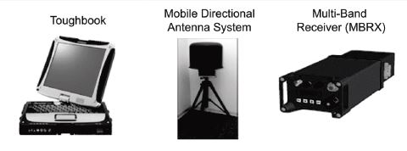

These three simple items can be rapidly employed to document, report, and receive information in a concise and low signal manner that will increase the lethality of an infantry platoon

14. When coordinating with higher and other units, create specified communication windows during the operation to where radios are on and communication is going back and forth such as reports, etc in order to mitigate the probability of the enemy detecting you and massing fires.

15. While on patrol, the use of radios is not necessary except for when commo windows are open. Rehearse and ensure your Soldiers know the plan when deaggregated. Utilize the KDDTMK (Known Event, Direction, Distance, Time of Travel, Method of Travel and Key Terrain (Grid) and Fires/Medevac) method for movements without GPS, again to mitigate digital exposure to the enemy.

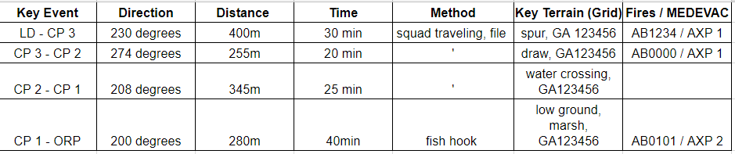

16. Certain criteria will need for radios to turn on, such as the following:
- Unplanned breaks in contact
- TIC
- Radio check before leader recon steps off
- The leader on the leader recon calls back to the ORP for far recognition, the ORP never calls the leader recon element first

17. If your communication is poor or not working, then remember to increase the length of the antenna, and point it in the direction of the receiving antenna you are trying to contact.

18. Utilize a commo wheel so that all 16 channels are programmed and everyone knows how many turns of the dial to get to certain stations. This will mitigate unnecessary movement, noise, and possible light from the radios.

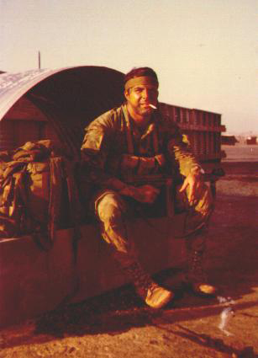
(US Army LRRP Commander, CPT Pete Dencker, Vietnam)

LEADER TIPS
(Combat Recon Manual B-720)

These are timeless tips of trade that have been indoctrinated and utilized since the Vietnam War era and are still applicable in the future of warfare.
      - No individual or team can practice or train too much or too often.
      - Teamwork is the key to success and will only come through constant training and rehearsal.
      - While on a mission, minimize fatigue, because tired men become careless.
      - If you show confidence, your team will have confidence.
      - Always have an alternate plan. Think ahead.
      - If you lose your temper, it will affect your judgment. Keep cool!
      - Don't be afraid to take advice from your team members.
      - Realism must be injected into all phases of training, such as zeroing weapons at targets in vegetation, using live training aids for PW snatch or ambush practice, etc.
      - Conduct at least half of your training at night.
      - Teams that have a good physical training program have fewer health problems.
      - Have a pre-mission and post-mission checklist to ensure that nothing is left behind.
      - Correct all personal, individual, and team errors on the spot.
      - Use tact when reprimanding your personnel, especially indigenous team members. If possible, take the man aside to criticize him. This enables him to react positively to the criticism, since he will not lose face, feel ridiculed or lose self-confidence.
      - Conduct English classes for your indigenous personnel, especially interpreters. Conduct classes for your U. S. personnel in your indigenous team members' language.
      - Don't set patterns in your operations.
      - Never do the obvious.
      - On patrol, stay alert at all times. You are never 100-percent safe until you are back home.
      - Have team members write down tips and lessons learned, and collect and consolidate them at the end of each mission.
      - Don't arbitrarily make all "tips of the trade" your team SOP. Always consider METT-TC.

WEAPONS TIPS
(Combat Recon Manual B-720)
Proper maintenance of ones weapons can be difference between life and death on the battlefield.
            - Never assume that your weapon is clean enough on an operation. CLEAN YOUR WEAPON DAILY.
            - Always carry rifle-cleaning equipment on operations - bore and chamber brushes, cleaning rag and patches, cleaning rod with handle and tip, and a small vial of weapons oil. A shaving brush is very useful.
            - When you fire your weapon, shoot low, particularly at night. Ricochets will kill just as well, and most people hit the ground when shooting starts.
            - Use one magazine full of tracer during infiltration and exfiltration. If taken under fire during infiltration or exfiltration, the tracers can be used to identify enemy positions to friendly air support.
            - The last three rounds in each magazine should be tracer to remind the firer that he needs a fresh magazine. Alternative: The last eight rounds are three tracers followed by five balls.
            - Quietly replace the cartridge in the chamber of your weapon each morning. Condensation may cause a malfunction.
            - Oil the selector switch on your weapon daily and work the switch back and forth, especially during rainy season. This will prevent the common occurrence of a stuck switch.
            - Always carry your weapon with the selector switch on "safe."
            - Use a plastic muzzle cap or tape to keep water and dirt out of the barrel.
            - To improve noise discipline, tape all sling swivels.
            - Rig the jungle sling so it is easily adjustable (for easy transition from rappel/fast rope to carry/fire). Tape a spare field dressing to the sling at the stock, using a single strip of wide cloth tape with a quick release tab.
            - Check all magazines before going on an operation to ensure they are clean, properly loaded and that the springs are oiled and functioning. Magazine problems cause the majority of weapons malfunctions.
            - Place magazines upside down in your pouches to keep out dirt and water.
            - Do not retrieve your first expended magazine during contact because it will consume valuable time.
            - If you use a PAQ-4 Aiming Light on an M16A2 rifle, you must modify the handguard to allow the thumb switch to travel far enough to activate the light. Using the serrated edge of your bayonet, file down the area under the thumb switch (between the eighth and tenth ribs from the slip ring) about 1/4." This is not a problem on the M16A2 Carbine, because the handguard is smaller.
M203 Tips
            - In dense vegetation, carry a 1:1 ratio of buckshot to HE, with 2-star clusters and 2-star parachutes for signaling aircraft.
            - In vegetation, point and trail men should be M203 gunners with buckshot in the chamber.
            - If you fire HE in the dense vegetation at night, be ready to have it bounce off a tree limb right back at you and go off in your face.
            - Oil your M203 with 30W or 40W motor oil, especially the trigger, safety housing, and slide, due to rain and humidity in dense vegetation.
SAW Tips
            - Silence ammo in plastic drums by making inserts from tablet-back cardboard covered with acetate. Cut to fit two per drum.
            - When moving, use a 30-round magazine in the SAW. Attach a drum in the ORP or once in position in a hasty ambush.
            - SAW drum pouches are tightly-fitted and tend to pop open when you drop into the prone. Use cloth tape with quick-release tabs to prevent this. The 2-quart canteen covers are acceptable substitutes.
Claymore Tips
            - Claymores are factory-packed "backwards;" i.e., to be emplaced from the firing position to the mine position, with the excess wire left at the mine. This is corrected by removing all the firing wire from the plastic spool, discarding the spool, re-rolling the wire "S"- or "Figure-8"- fashion, and replacing it in the bag so as to enable the mine to be emplaced first and the wire laid back to the firing position. The clacker with circuit tester attached is preconnected to the firing wire and stowed in the mine pouch. The unit commander must make the decision to either prime the mine before departing on the mission, or to only put the shipping plugs on the electric and nonelectric blasting caps to speed priming during emplacement.
            - Dual-prime each claymore for both electric and nonelectric firing. The time fuses should be pre-cut for 30-, 60-, or 120-second delay, for pursuit/break-contact situations. However, the burn time on the fuse becomes undependable the longer the fuse is exposed to wet/humid conditions.
            - Waterproof your nonelectric firing systems.
            - Carry the claymore in the rucksack so it's immediately accessible, so after breaking contact it can be quickly armed and emplaced on the back trail (even while it's still in the ruck) to delay pursuers.
            - When placing claymores around your position (OP, ambush, RON, etc.), they should be emplaced one at a time by two men.
            - Never emplace a claymore in a position that prevents you from having visual contact with it.
            - Because you only emplace a claymore where you can observe it, if you are operating in dense vegetation, you may consider cutting your firing wire in half since you won't use more than 50 feet/5 meters of wire, easing emplacement and recovery and cutting weight.
            - Emplace each claymore so the blast parallels the team, and the firing wire does not lead straight back to the team position from the mine. If the claymores are turned around by the enemy, they will not point at the team.
            - Determine in advance who will fire each claymore and who will give the command or signal to fire.
Grenade Tips
            - Make continuous daily checks on all grenades when on patrol to ensure that the primers are not coming unscrewed.
            - Do not bend the pins on the grenades flat. The rings are too hard to pull when needed.
            - Fold paper tape through the rings of grenades and tape the ring to the body of the grenade. The paper tape will tear for fast use, while plastic or cloth tape will not. It also keeps the ring open for your finger, stops noise and prevents snagging.
            - All team members should carry a mixture of fragmentation, CS and WP grenades on their belts for the following reasons:
              - Fragmentation grenades are good for inflicting casualties.
              - CS grenades are ideal for stopping or slowing down enemy troops and dogs pursuing your team, and are effective in damp and wet weather, whereas CS powder will dissipate.
              - WP grenades have a great psychological effect against enemy troops and can be used for the same purpose as CS grenades. The use of CS and WP at the same time will more than double their effectiveness.
            - Thoroughly train and test your indigenous troops in grenade-throwing, particularly WP. Not all of them might be adept at baseball-style throwing, or be able to get much distance.
            - Violet and red are the smoke colors most visible from the air. However, in dense vegetation or wet weather, use WP to signal aircraft.
            - Notify aircraft before signaling with WP. Gunships or fighter-bombers may mistake it for a marking rocket indicating an enemy position and attack you.
            - Camouflage smoke, CS, and WP grenades, using black or OD spray paint.
            - Smoke grenades should be carried in or on the pack and not on the LCE. You don't fight with smoke grenades, and if you need one, 99 times out of 100, you will have time to get it from your pack.
            - Each team should carry one thermite grenade for destruction of either friendly or enemy equipment.
            - DO NOT carry rubber baseball-style CS grenades. They were designed for riot control on city streets and are inadequate in dense vegetation.
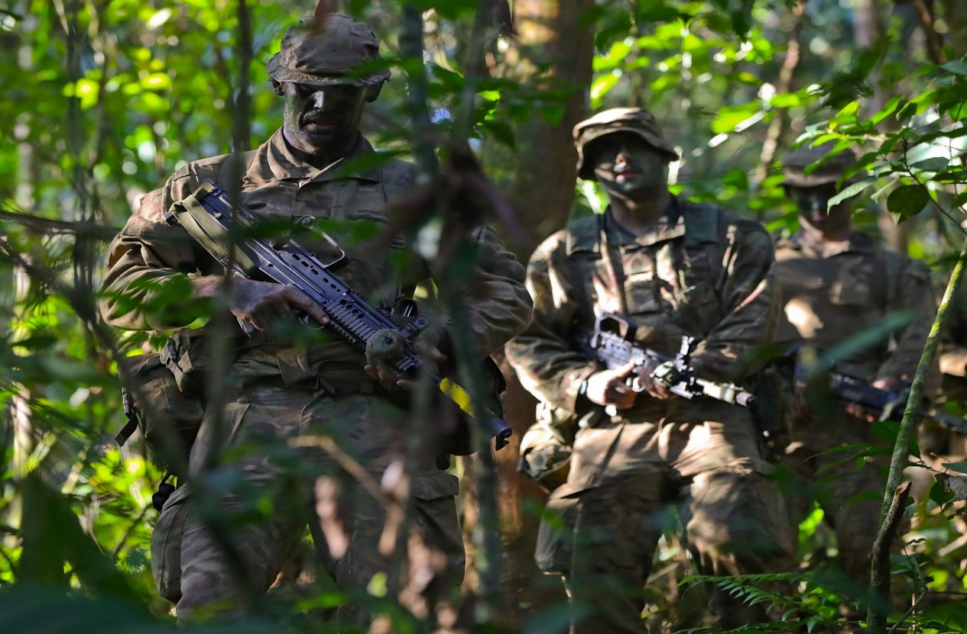
(Royal Marines Conducting Dismounted Reconnaissance, showing the importance of fighting with light loads to increase maneuverability and survivability on the battlefield)

LCE/RUCK TIPS
(Combat Recon Manual B-720)

This section aims to stress the importance of allowing Soldiers to manipulate their equipment and gear to better facilitate operations.

      - Be sure that all snaps and buckles are taped. Do not use paper tape.
      - Always carry a sharp knife or bayonet on patrol.
      - Always wear your LCE buckled when not sleeping. If you're wounded, your teammates can drag you by your LCE shoulder straps.
      - For survival, each individual should carry a cut-down MRE in his pants' cargo pocket, and one tube of bouillon cubes in the first aid pouch on his LCE. One bouillon cube dissolved in one canteen of water will provide energy for one or two days.
      - Don't use 2-quart canteen covers to carry 30-round magazines. You can fit eight mags in one, but once you take the first mag out, the others rattle loudly and spill out easily. Use regular ammo pouches.
      - Sew a long slim pocket on the side of your ruck to accommodate the long antenna, or use an accessory kit bag clipped and tied to the side of the ruck.
      - Snap the snap link on your rucksack through the loop in the upper portion of your rucksack carrying straps or the frame, so you won't lose it during exfil when you snap it on a ladder or extraction fastrope.
      - Insect repellent leaks and spills easily, so put it in a ziplock bag and isolate it from your other equipment in the rucksack. Also, squeeze air from the repellent container and screw the cap on firmly.
      - Always use the water from canteens in or on your rucksack before using water in the canteens on your belt. This will ensure a supply of water should you ditch or lose your rucksack.
      - Test the shoulder straps on the rucksack before packing it for patrol. Always carry some parachute cord to repair straps on patrol.
      - Use a waterproof bag in the rucksack to protect equipment while on patrol. This is extremely important during the rainy season.
      - Camouflage your rucksack with black spray paint.

Remain Overnight (RON) Tips aka ORP Establishment
(Combat Recon Manual B-720)

“RON’s are normally easy to find, just look for a place in dense vegetation that even an animal would not sleep in and that is your spot… The last thing you should look for is a comfortable spot; your own common sense should tell you that’s wrong… In the mountainous areas of Laos, there were many a night were I slept with a tree between my legs so I didn’t roll down the side of a mountain.”- Jim Bolen, SOG Veteran and TL of Recon Team Auger.

  - Practice proper RON procedures when your team is training, even if you are on a rifle range. Take advantage of all training opportunities.
  - Select a tentative RON site from your map at least two hours in advance.
  - After passing a suitable RON site, "fish-hook" back and move into your selected position so that you can observe your own trail.
  - Don't form the common habit of constantly turning to the same direction (always to the left, or always to the right) when fish-hooking.
  - When in position, personnel should keep their equipment on and remain alert until the perimeter has been checked for 360 degrees at a distance of no less than 50 meters.
  - Packs should not be taken off until it is dark.
  - When deploying the team for RON, place the point man in a position opposite the most likely avenue of approach, to lead the team out in case of emergency.
  - Use aiming stakes to help orient weapons toward avenues of approach.
  - Azimuths (OT lines) and distances to preplanned targets should be recorded prior to nightfall. Nearby large trees or pre-positioned stakes can aid as hasty reference points for calling in artillery at night.
  - Prior to dark, the team leader should tell each man the primary and alternate rally points.
  - One half of the team should have their compasses set for the primary rally point and the other half for the alternate. If the enemy comes from the direction of the primary rally point, any man with the azimuth of the alternate rally point set on his compass can lead the team out.
  - A buddy system should be established in case casualties are taken at night. Each man will take care of his buddy and his buddy's equipment if the buddy is wounded, injured, or killed.
  - The pack or rucksack can be used as a pillow. However, ensure that the carrying straps are in the "up" position for easy insertion of the arms in case of rapid withdrawal.
  - It is permissible to unhook your LCE in the RON, but it should never be taken completely off at any time during the entire stay in the field.
  - A poncho, jungle sweater and rain jacket are sufficient for sleeping.
  - If a person coughs in his sleep, give him as much cough syrup as he can tolerate without going punchy.
  - Team members should not "bunch up" or sleep next to each other. One grenade or burst of fire could get them all. In small reconnaissance patrols, all team members should be able to touch each other without moving from position. When this is not possible due to the terrain, breakable cord can be tied from patrol member to patrol member for alerting each other at night.
  - Know what your next day's plans are before settling down for the night.
  - At dark, each team member should take out two or three grenades and place them near at hand for use if hit at night. Set them so they won't roll away if they're accidentally bumped.
  - Wait until last light to emplace your claymores around your RON site so you won't lose them if you're run out of your RON before dark.
  - When the enemy discovers your RON at night, use frags first, then claymores (explosions are disorienting and don't necessarily give your position away), then M16/M203 (the muzzle flashes will pinpoint your location), and lastly SAW/M60 (automatic weapons always draw maximum return fire).
  - In some instances, it is better not to put claymores around RON positions but to rely on the use of CS grenades instead, for the following reasons:
    - When claymores have been put out and the enemy is discovered to be moving in on the team, the team might stay in place too long, waiting for the enemy to enter the killing zone.
    - If the team discovers the enemy moving in on them, the enemy will normally be "on line," not knowing the exact position of the team. If no claymores are out, predesignated team members will throw CS grenades in the direction of the enemy force. After the gas begins to disperse, the team can withdraw. When the enemy is hit with the CS, he will normally panic. If he has gas masks with him and puts them on, he will not see clearly. If he does not have them, he will run away and may even fire his weapons indiscriminately, causing overall confusion and panic. In either case, the team has a good chance to escape, unharmed and unseen.
    - If a claymore is triggered, a grenade thrown or a rifle fired, the enemy might be able to orient on the team, flank it, and box it in.
    - If claymores are used around an RON site, consider taping plastic packets of CS to the front of the mines.
  - Do not send radio transmissions from your RON site unless they are absolutely necessary. Be prepared to move if you do transmit.
  - Never smoke or chew tobacco or eat chow in your RON position. The odor of the food or tobacco will give your position away.
  - All team members should be awake, alert, and ready to move prior to first light.
  - Another 360-degree check of the perimeter at a distance of at least 50 meters should be made prior to recovering claymores and sensors and moving out.
A thorough check should be made of the RON site just before departure to ensure that nothing is left behind and that the entire site is sterile.
  - Be alert when leaving your RON. If you have been seen, you will probably be attacked or ambushed within 300 meters.
  - Habits are easily formed around certain times of the day. For example, some teams always move into a RON site at 1830 or into a noon break position at exactly 1100 every day. If the enemy has been observing you, he will notice this and plan an ambush for you.

Breaking Out of Encirclement/Immediate Dispersion Tips
(Combat Recon Manual B-52)

In the event an element encounters the enemy disruption zone and is unable to create an advantageous situation, the unit must utilize the following tips and procedures. Additionally, a dispersion plan of action is introduced to increase the survivability of the restructured force.

- General: Too many times Recon Teams which have not planned for or practiced methods to "break out" from the encirclement have been encircled by the enemy. The following methods and suggestions have worked for others in the past and it is hoped that this will be of assistance to you in the future if you find yourself and your team in such a situation.
        - Team encircled, the sooner you attempt to break out the better chance you will have to do so effectively and with the least amount of casualties. The longer you wait the stronger the enemy becomes.

- Preparations for breaking out of encirclement: Plans must be made prior to the break out attempt to take care of the following:
- Rucksacks and equipment left behind must be destroyed by someone.
- Dead must be left behind. Someone must remove any classified documents such as SOIs, notebooks, maps, etc.
- One or two persons, depending upon the size of the team must have the mission, during the break out assault, of rear security. This will include assisting any personnel who may be wounded before or during the attempt. Additionally they should recover documents from personnel killed during the break out movement. No attempt should be mode to try to take KlAs with the team.
- Keep in mind that the successful completion of your mission depends on getting the information back to headquarters. All personnel must be reminded of the important information the team has observed.
- All sensitive equipment to include papers should be destroyed or taken with the team.

- Formation to use: The most effective method a small element can use (5 to 12 man teams) is to form into a pyramid configuration, with the base of the pyramid leading. The following actions should take place:
- The teams forms into position.
- CS rounds from M320s and/or CS grenades are fired or thrown to the flanks.
- WP grenades are thrown to the rear.
- A claymore mine and/or grenades are fired or thrown in the direction the team will move.
- Immediately after the claymore and/or grenades go off to the front, the team moves out.
- The first element of line will fire on full automatic. The others hold fire.
- When the first elements' magazines are empty, the second element moves through them and continues the fire.
- When the second element has emptied their magazines the first element will have reloaded and will pass through them, taking up the assault but will only fire on semi-automatic.
- Once the team starts to move it must move rapidly, but not run, and never stop until completely out of the encirclement.

- Supporting fires: Artillery, naval gunships, helicopter gunships and TAG Air, if available, should be used to assist your break out attempt. These are discussed below:
- Supporting artillery fire, within range, can be effectively employed to pave your way out of an encirclement or near encirclement. When foul or inclement weather prevents your use of helicopter or TAC air for support, you must use artillery if available. Artillery support, when available, should also be requested at the first sign of trouble for many times it can be firing in your direction before air support can arrive on station to assist you. It is a common practice, as you learned in basic training, that when you are subjected to incoming mortar or artillery fire, you move out of the area as quickly as possible. Enemy forces follow this same doctrine. When you desire to break out, with the aid of artillery, first have the fires placed completely around your position, then having selected your desired heading, "walk" the artillery in front of you. This will effectively lead you out of the danger area and you may even pick up a shell shocked or wounded PW on your way out.
- Helicopter gunships can assist you with almost continuous close in fire support, firing directly in front and to the rear during your break out attempt. The effect this fire will have is dependent upon the density of the vegetation, location of your team, and whether or not your supporting aircraft crews can see you or your signals. You may have to direct their fire by adjusting from the strike of the rounds and rockets.
- Tactical airstrikes can assist you in your attempt to break out of an encirclement. To do this, call for bombs in the direction you desire to move. Since the enemy will get as close to the team as possible to avoid airstrikes, it is preferred to call in the bombs first and then hove the TAC Air fire his machine guns and 20mm in front of you as you move out. They can place machine gun fire much closer to you than bombs.
- Having a JTAC and/or JFO part of your formation increases the lethality of utilizing these assets when needing to break out of enemy encirclements.
5. If the platoon is targeted via one of the enemies detection systems and mass artillery fires are imminent, or if the enemy utilizes UAS and the patrol is spotted, the patrol must conduct a dispersion battle drill.
- Prior to initiating movement, each member on the patrol is familiar with the locations of pertinent rendezvous locations (RV), designated areas of recovery (DAR), signaling reference point (SARDOT), and the patrol marking SOP.
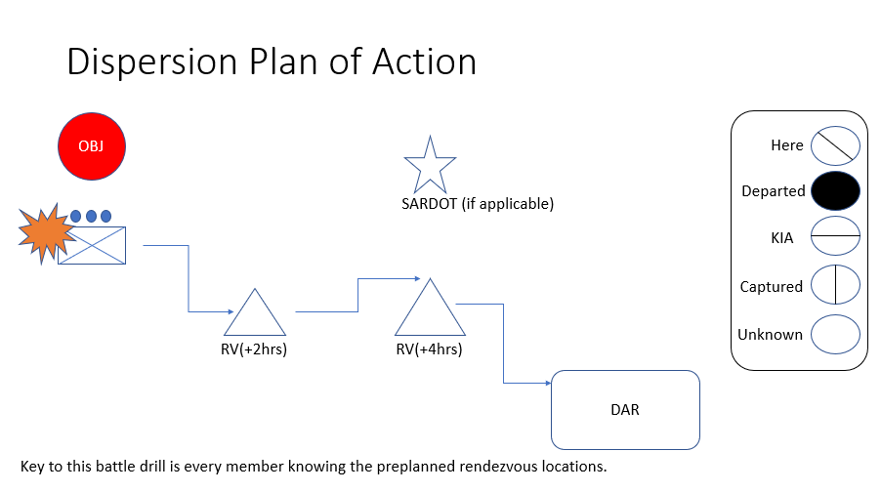
Based off of the 5-10-20 minute time window of Russian target acquisition, if a platoon is discovered via UAS or sniper defense, then there is a 20 minute window until an artillery barrage has rounds impacting the area. If the ability to quickly de-aggregate, maneuver, and find cover/concealment or press the offensive is not attainable, then the platoon must utilize the dispersion plan of action.

Movement Technique Tips
(Combat Recon Manual B-52)

“Our first reaction to contact was murderous aggressive assault. We would hit them so hard and fast that they would back off and call for help. That gave us a few minutes to grab some decent terrain or try and slide off and run hard and fast to get distance. This became harder when they started to deploy anit-recon units against us.” – Nick Brokhausen, SOG Veteran and member of Recon Team Habu

- Movement Technique: There are five basic techniques of movement that can be employed by small recon teams to avoid being detected or encircled by enemy forces. Each of these are explained and discussed below:
- The Box Technique: This is a simple and effective method to use and takes very little practice to employ. From a given point the team moves out on a set azimuth for specific set number of meters or paces, for example let's say 35 meters. The team then makes a 90 degree turn and moves 75 meters, then another 90 degree turns for 30 meters, another 90 degrees turn for 30 meters, another for 30 meters. You will have formed a "box". At this point you can do any one of several things. You can wait in ambush for your trackers, or pursuers, walk backwards across your old trail, if the vegetation and soil is such that it is impossible to hide your tracks, or continue on. When you move out, after having formed your first "box", move for another 50 to 75 meters and form another box. By forming these boxes, it will enable you to ambush your pursuers and will definitely confuse any trackers as to your direction of movement. It will also discourage the enemy if you occasionally booby-trap your back trail. You can maintain a general heading that you desire to go without the enemy force becoming aware of it until you are out of the danger area or until he loses you completely. A word of caution though, and that is not to continually make your boxes the same size or to continually turn to the right or left. Never set a definite pattern of movement. Examples follow:
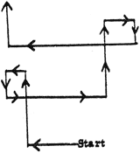
b. The Figure Eight Technique: The figure eight method is very similar to the box technique in that you are doing basically the same thing except here you will be making circles instead of squares. An example is shown below:
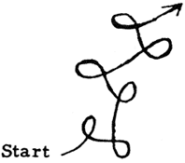
c. Angle Technique: Another effective method to use in evasion and takes very little practice to employ. The patrol will change the direction of movement from the present patrol route of march in a series of angle movements. For example the team will make on angle move to change direction such as 30 degrees, 45 degrees, 70 degrees for a hundred or so meters, then do it again to confuse the enemy. An example is shown below:
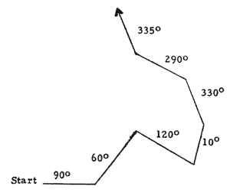

d. Step Technique: The simple method of changing the route of march in 90 degree turns for a distance of a hundred or so meters. An example is shown below:
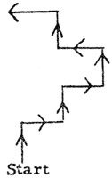
e. Skip Method: An effective method that requires practice to employ. The patrol will stop in place and on command wit! move left or right of present route. Each member will move as carefully as possible not to make a trail or leave tell tale signs to the flank for a distance of 20-30 meters and then resume the patrol's former route of march. The team leader should send the point man ahead to make a false trail for 30 to 50 meters before using the skip method. This method takes practice and team members have to be careful not to leave signs as they move. See the example:
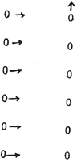
- Additional Information:
  - Never set a pattern if one technique does not work, change to another.
  - In both the box and figure eight techniques the size of the squares or circles will depend on the terrain and vegetation. The box technique is extremely effective at night. Both methods can be used to find a hold or weak point in the enemies encircling perimeter from which to break out. Both techniques have been used successfully in the past by recon teams. One survivor, of an ambushed recon team, succeeded for three days, in ambushing and killing six enemy pursuers by employing the figure eight method before being spotted and recovered by searching aircraft.
  - During the dry season CS powder spread over your back trail is extremely helpful in stopping dogs.
  - During the rainy season CS powder is almost useless or very ineffective against dogs. It is much more effective to drop a CS grenade during wet weather since it will hang low to the ground and remain effective against enemy personnel, especially those that do not have or carry protective masks.
  - In closing I might remind you that your tactics and techniques are only as good or effective as you make them. This can only be done through constant practice, training and rehearsals.

Infiltration/Exfiltration Tips
(Modern Recon Manual B-720)

"Now I recall the Recon Marines ragged, filthy cammie shirted young men in green paint who move silent like the fog with deadly purpose in their eyes. Swift, Silent, Deadly.... I Smile"
- GYSGT Correl, USMC, Retired Recon Marine

      - When loading the aircraft for infiltration, ensure the team is seated so that they can exit the proper door.
      - Load the team in reverse order.
      - Sudden shifts of weight in flight will cause temporary loss of aircraft control. Don't cause any.
      - The team leader and pilot will determine direction of approach to the infiltration LZ.
      - The team leader will wear a headset to talk with the pilot until just before touchdown/insertion.
      - The team leader will follow the flight with his 1:50,000 map from the FOB to his infiltration LZ. The team leader, not the pilot, is the man ultimately responsible for where the team is inserted.
      - When unloading a UH-1 at the hover, team members will unload one at a time to enable the pilot to stabilize his aircraft.
      - If the aircraft must hover more than 6-8 feet off the ground, use a fast rope/ladder to avoid injury to team members.
      - If the first man exits the aircraft under fire, the entire team will exit the aircraft.
      - If the aircraft crashes, the team leader is in command on the ground. He will do the following: · Secure an area 50 meters in front of the aircraft. ·
        - Account for his team and aircrew.
        - Call for a rescue aircraft.
        - Treat casualties.
        - With the pilot return to the aircraft to zero the radios and secures, turn off the gas, destroy the battery, and remove maps, CEOIs, pilot's notebooks, weapons (door guns) and ammunition. · Evacuate aircrew and casualties (including KIA) on the first aircraft.
        - Evacuate remainder of team on the last aircraft.
        - Inform your personnel in what order they will be extracted prior to the arrival of the extraction aircraft. The LZ should be secured prior to the arrival of the aircraft.
        - Give the pilot an LZ description and approach heading.
        - Notify aircraft before firing pen-flares, because they look like tracers.
      - Never turn your back without covering fire. If none is available, return fire while backing off.
      - The assistant team leader is the first to enter the exfiltration aircraft and counts the team aboard. The team leader or senior remaining detachment member is the last to enter aircraft, and the only man who can give the pilot the O.K. to lift off. Make sure you have everyone.
      - During extraction, do not fire weapons from helicopters after leaving the LZ, because a helicopter may be passing under you without your knowledge.
      - In selection of LZs, avoid likely or large LZs.

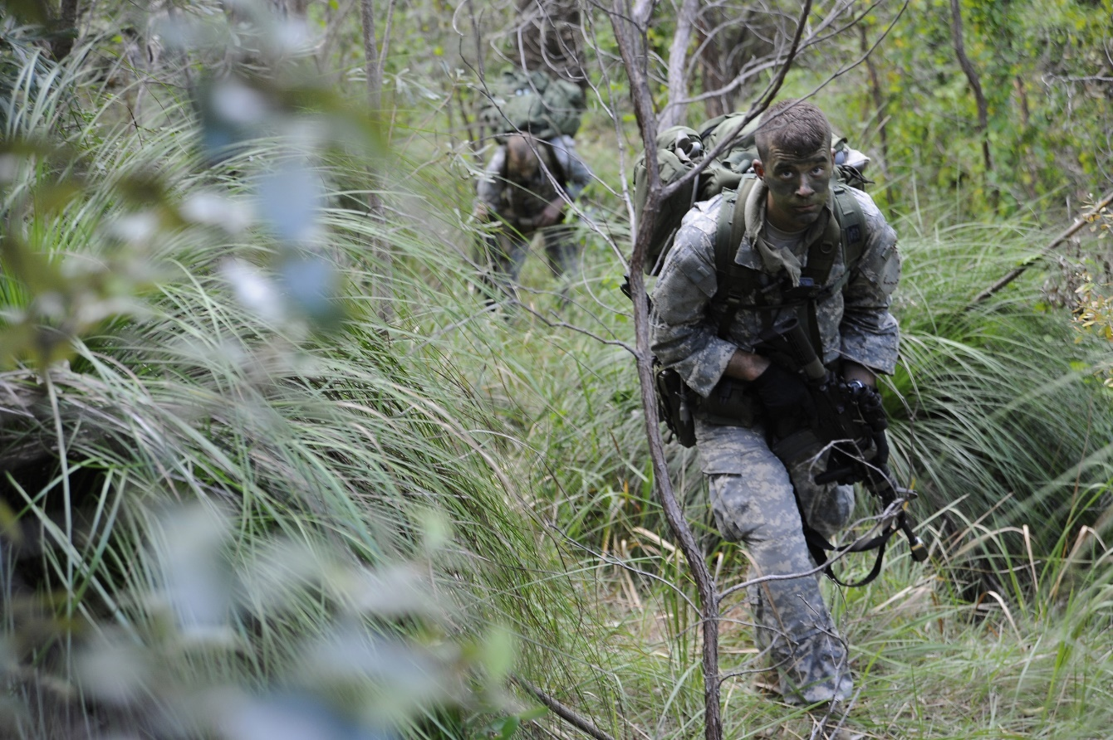
(Dismounted reconnaissance training)
RECONNAISSANCE PATROL TIPS
(Combat Recon Manual B-720)

The restructured infantry platoons can utilize these timeless tips of the trade to increase lethality and survivability.

            - When making an aerial visual reconnaissance (VRs), always mark every LZ within and adjacent to your AO on your map. Plan the route of march so that you will always know the distance and azimuth to the nearest LZ.
            - Always plan a primary exfiltration LZ and two or more alternates. 130. Your alternate LZs should be in the direction of your E. & E. corridor.
            - Don't cut off too much of the map showing your AO. Always keep at least 5-10 km surrounding your AO as "running room."
            - Base the number of canteens per man on the weather and availability of water in the AO. Select water points when planning your route of march.
            - Inspect each team member's uniform and equipment, especially radios, sensors, NVGs, cameras and strobe lights, prior to departure on a mission.
            - Check all team members prior to departing home base for passes, ID cards, notebooks with writing in them, cigarettes, lighters and rings with insignia, etc. Personnel should only carry dog tags while on patrol.
            - Always carry maps and notebooks in waterproof containers.
            - Use a pencil to make notes during an operation. Ink smears when it becomes wet; lead does not.
            - Use "Storm-Safe" or "Wet-Notes" waterproof notebooks (commercially available) so you can take notes, make sketches, etc., while it's raining.
            - During the rainy season, take extra cough medicine and codeine on patrol.
            - During the dry season, do not urinate on rocks or leaves, because the wet spot may be seen, and the odor will carry. Use a hole or small crevice.
            - The location and proper use of morphine should be known by all team members.
            - Each team member should carry maps, notebooks, and CEOIs in the same pockets of each uniform, for hasty removal by other team members if someone becomes a casualty.
            - All survival equipment should be tied or secured to the uniform or harness to prevent loss if pockets become torn, etc.
            - Do not take Zippo-style cigarette lighters to the field, as they make too much noise when opening and closing. Of course: you never smoke on patrol, because the odor travels long distances in the forest.
            - Have designated primary and alternate rally points and LZs at all times. The team leader is responsible for ensuring that each team member knows the azimuth and distance to each rally point/LZ.
            - Never take pictures of team members while on patrol. If the enemy captures the camera, he will have gained valuable intelligence.
            - At least two pen lights with infrared filters should be carried by the team.
            - While on patrol, move 20 minutes and halt and listen for 10 minutes. Listen half the amount of time you move. Move and halt at irregular intervals.
            - Deviate from your route of march often. Never move in a straight line.
            - Never move along bottoms, ridgelines, or other easy and obvious routes. Always use the military crest of hills for your movement.
            - Stay alert at all times. You are never 100-percent safe until you are back home.
            - Avoid overconfidence, it leads to carelessness. Just because you haven't seen any sign of the enemy for 3 or 4 days doesn't mean that he isn't there or hasn't seen you.
            - A large percentage of patrols have been compromised due to poor noise discipline. Speak and talk quietly.
            - Never break limbs or branches on trees or bushes, or you will leave a clear trail for the enemy to follow.
            - Put insect/leech repellent around tops of boots, on pants fly, belt, and cuffs to stop leeches and insects.
            - Do most of your moving during the morning hours to conserve water. However, never be afraid to move at night, especially if you think your RON has been compromised.
            - Continually check to ensure your point man is on the correct azimuth. Change direction often.
            - If followed by trackers, change direction of movement often and attempt to evade or ambush them. They make good PWs.
            - Force yourself to cough whenever a high performance aircraft passes over. It will clear your throat, ease tension, and cannot be heard. If you must cough, cough into your hat or neckerchief to smother the noise.
            - Never take your web gear off, day or night. In an area where it is necessary to put on jungle sweaters/gore-tex jackets at night, no more than two patrol members should do so at a time. Take the sweaters/jackets off the next morning to prevent colds and overheating.
            - If you change socks, especially in the rainy season, try to wait until RON and have no more than two patrol members change socks at one time. Never take off both boots at the same time.
            - When a team member starts to come down with immersion foot, stop in a secure position, remove the injured person's boots, dry off his feet, put foot powder on them and place a poncho over them so they can dry out. Continued walking will only aggravate the injury, ensuring that the man will become a casualty, and halting any further progress of the team.
            - Desenex Ointment or Vaseline rubbed on the feet during the rainy season or in wet conditions will aid in the prevention of immersion foot. Put on the hands, it will also help avoid chapping.
            - All personnel should camouflage faces and backs of hands in the morning, at noon and in RON or ORP positions.
            - Never cook or build heating fires on patrol.
            - No more than 25-percent of personnel should eat chow at any one time. The rest of the team should be on security. 166. Whenever the team makes an extended halt, always check 50 meters out from the perimeter.
            - All team members should take notes while on an operation and compare them nightly.
            - Each man on a team must continually observe the men in front of and behind him (as well as the other team members) for hand and arm signals.
            - A reconnaissance team with a mine emplacement mission should never place more than one mine (AP or AT) in one small section of the road or trail at a time. If more than one is set out, the team is just resupplying the enemy, because when a mine goes off, a search will be made of the immediate area for others, and they will surely be found.
            - If your mission calls for emplacing a mine in a road, take an extra fuse along, in case one is lost.
            - When crossing streams observe first for activity, then send security across to check the far side. Then cross the rest of the patrol one at a time, with each man taking water as he crosses. If necessary, have all personnel cross prior to getting water.
            - Treat all trails (old and new), streams, hilltops, ridgelines, and open areas as danger areas.
            - Carry one extra pair of socks, plus foot powder, while on patrol, especially during the rainy season. Each team member should also carry an oversized pair of thick socks to pull over his boots when walking or crossing a trail or stream to disguise his tracks.
            - During rest halts, don't take off your pack or leave your weapon. During long breaks, such as for noon chow, don't take off your pack until your perimeter has been checked at least 50 meters out for 360 degrees.
            - During breaks, throw nothing on the ground. Stow trash in your ruck immediately. Don't bury trash, because trackers or animals will dig it up.
            - If you hear people speaking, move close enough to hear what they are saying, and take notes.
            - A dead enemy's shirt and the contents of his pockets and pack are normally more valuable than his weapon.
            - If the enemy is pursuing you, deploy delay grenades and/or delay claymores of 60-120 seconds. In addition, throw CS grenades to your rear and flanks. Give the enemy a reason or excuse to quit.
            - If you're being pursued at night, HC (white smoke) and CS grenades in combination will help you break contact, blind NVGs, and screen your escape.

Forward Air Controller (FAC) / Joint Fires Observer (JFO) Tips

The addition of a JFO qualified Soldier provides ground force commanders with an increased lethality to observe joint fires and integrate multiple echelons of fires ranging from rotary wing to naval gunships.

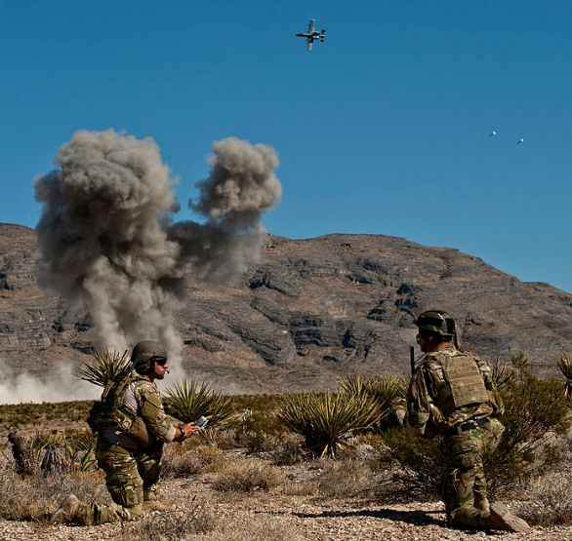
(Figure 6: showing a JFO and JTAC coordinating joint fires)
- Always give the FAC a complete description of your target and target area. Use the JFO SITREP report format.
- Make adjustments for the FAC after each round and after each aircraft makes a pass.
- Give the track that you request, always try to put strike across your front. Do not call air in with its strike track coming directly across your position, from the front or rear. NOTE: A strike that is a fraction too soon or late could land in your position. IT HAS HAPPENED BEFORE.
- Always check with the FAC(A) on coordinates given and with the aircraft on laser codes if conducting a laser handoff or ground based laze for ordnance.
- Whenever possible, try to give a BDA (bomb damage assessment) to the FAC.
- A FAC can be used effectively to direct a team in contact to LZ's. A FAC can also provide an airstrike to prep an exfil LZ for a team before it reaches the LZ. This is a good technique to employ in dangerous areas.
- A FAC can be used to break off contact while a patrol is waiting for strike craft. A low pass or a pass firing a marking round may make the enemy think they are being attacked, thus causing them to withdraw.
- When directing Shadow or other UAS type aircraft over your target do not let him fly directly over the targets.
- Ask Shadow to drop a flare and direct him to the target from that flare. Make adjustments from his tracer impact area to insure that you get full target coverage.
- Forward Observers should utilize the Keyhole Method when coordinating Aircraft overhead. This must work in conjunction with the suppression of enemy Air Defense Assets resulting in a SED (Suppression of Enemy Defense) mission. See Appendix X for SED mission brief
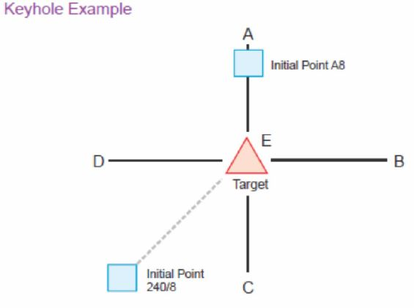
- During the planning process and when the Platoon Leader is conducting coordination with CAS (Close Air Support) elements, it is imperative that the use of a Global Reference Graphic or an Urban Reference Graphic are able to be employed if needed. Each will allow a
soldier to resort to previous analog methods. Below are examples:
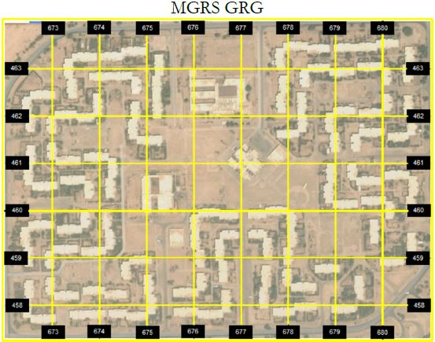
A GRG is gridded reference graphic. The grid can be MGRS of other means. However, on this GRG we noticed that each square is a 6-digit grid. With that considered, we know each square equals 100 meters. We can use this as a measure tool when we develop range estimations as well.
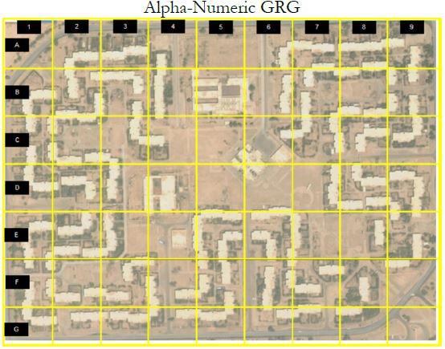

This image is an Alpha-Numeric GRG. You see that it is also a gridded graphic. This is similar to the city map in a phonebook. For this one all that is required to say is scan block F-2 and it will narrow down where the aircraft needs to follow along. Unlike the MGRS version, there is not size standard for those blocks.

- For Urban Enviroments the Sectored Methode of breaking up a URG is avalible for use. This can enable a Forward Observer the ability to talk an aircraft on to a target with minimal transmissions. Additionally this method should only be conducted over frequencies that are Cypher Text, Frequency Hop.
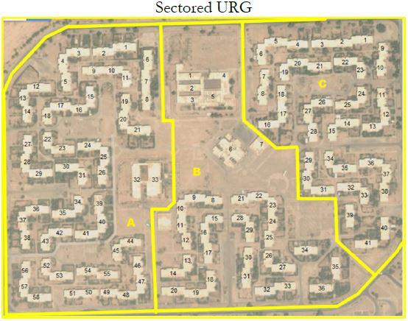
On this image, notice that the city is sectored by neighborhood or geographic boundaries. This image has no gridded reference but it does have a specifying reference. Due to it not having a grid it is a URG (Urban Reference Graphic). To locate a target for an aircraft simple say Sector A, compound 53. This is the easiest imagery to correlate with, however it does become very time consuming to produce.

Planning Considerations for Joint Fire Observers
Once a Infantry platoon has been given their Priority Intelligence Requirements (PIR) for a mission, they are able to determine more effective ways to advocate for assets on the battlefield. During the planning process, commanders must begin to imagine how to fight will go down, and how each asset they control will play an individual part. Junior officers must take these assessments from commanders and rapidly assign them as the tactical situation develops.

Current threats to the United States use of Precision Guided Munitions (PGMs) in Iraq and Afghanistan, have come from minimal ADA assets. With a more capable opponent, support from these highly lethal platforms becomes less available
(Figure 7 shows the different range assets that enemy ADA assets are capable of reaching)

Figure 7 shows that the closer US assets come to protect ground forces, the greater danger they will face. Fighting against a peer level enemy will greatly increase this distance and decrease the effectiveness of US assets.

To prevent these peer level assets from deterring US air support, greater planning from ground commanders can allow the correct capabilities to be utilized against these threats. This will reduce standoff from the infantry platoon operating autonomously and the assets they may eventually need to call into the fight.
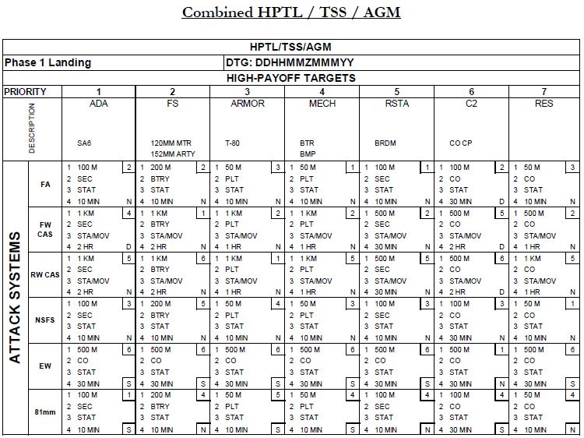
(Figure 8: asset to threat matrix showing what assets to attack adversaries with)
Reading and Assigning the Target Matrix:
1. This number represents Target Location Error. This is how close dropped ordinance must land to achieve the effect desired by the ground force commander on the target.
2. Engagement Criteria
3. Activity of the Target
4. Timeliness of Acquisition
*Top Right number of each box is the Asset Prioritization
*Bottom Right letter represents the desired effects on target: Destroyed, Suppressed, Neutralized

The Target Matrix above can help appropriately pair assets to differing priorities of targets, as well as layer how to destroy enemy weapons systems in order of the threats they present to U.S. capabilities. Once an enemy ADA weapon system is destroyed, a commander can use this to reassign air assets in that given Operational Area.

Special Consideration to Enemy Drone Capabilities

1. With the growing threat that enemy drone capabilities pose to the United States military operating abroad, each commander must ensure their Soldiers know which assets are organic to their unit. Any asset brought in overhead of a dismounted element must immediately be identified as either friendly or enemy.

2. Current procedure for if an enemy drone is found to be operating near a dismounted element is to halt and decrease any exposure by utilizing cover and concealment. Determine if the drone is observing the dismounted element. If it is not, all movement will remain static until the drone has vacated the premises.

3. If it is clear the drone has spotted the dismounted element, the soldier carrying the drone rifle will engage the drone to neutralize its while the remainder of the element will initiate the dispersion plan of action. This must happen in rapid succession since any video feed that a drone is providing will show it being downed and the likelihood of indirect assets being called upon the drones last known location are high.
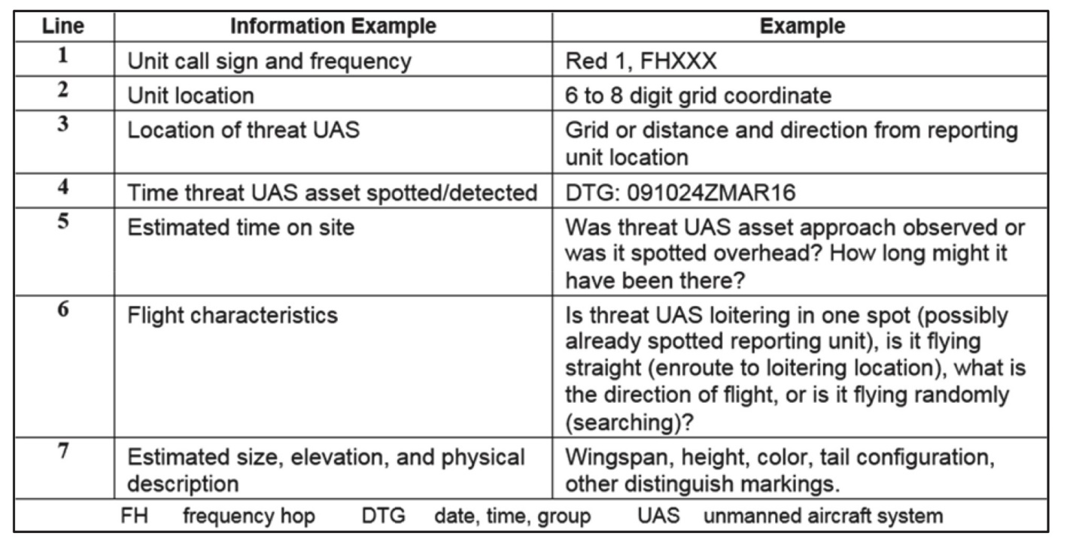
Recommended enemy UAS report format

Sustaining the Restructured Force

A primary means of resupplying the proposed infantry platoon is through the use of airdrop operations. Therefore, utilizing pathfinder operations enhances the sustainability of the restructured force. Pathfinder qualified Soldiers increase the lethality of the unit and provide unique capabilities to conduct sustainability operations, maneuver combat power, and utilize deception in today’s battlefield. This handbook is not attempting to qualify someone as a Pathfinder, but it is highlighting key aspects in order to facilitate necessary resupply operations through the means of airdrop operation. For more detailed integration of Pathfinder Operations, refer to FM 3-21.38.

Resupplying a forward operating unit creates an opportunity for the enemy to exploit a large military operation in a contested area. However, with the proposed changes to the light infantry platoon, we can avoid these possible pitfalls. Commanders must plan for limited and secure methods of resupply. One method is the Army GMRS drop zone. It does not require the Soldiers on the ground to be in contact with the supporting unit and is possible in both night and daytime airdrop operations. When planning to resupply and sustain with the proposed light infantry platoon changes, it is recommended to follow a PACE plan in how to maintain self-sufficiency:
- Primary: airdrop operations
- Alternate: uniformed, ground resupply
- Contingency: partisan/local national
- Emergency: scavenging

The diagram below represents the primary process: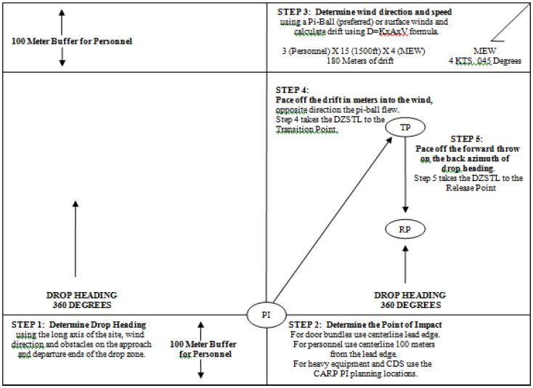

Other methods to resupply units will be determined during the planning process to allow limited exposure to U.S. assets as well as prevent the ground team from being compromised. The location of the drop zone needs to allow for limited observation from enemy forces and the supporting aviation unit should be briefed on flight altitudes that will increase their survivability and prevent them from being decisively engaged.

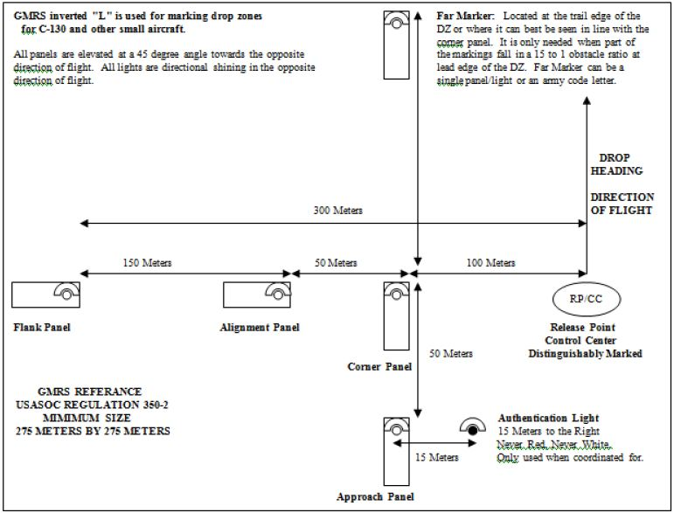

Once the Release Point is Determined and the Point of Impact is found, the rest of the Drop Zone markings can be emplaced. These markings will be VS-17 panels in the daytime and white omni-directional lights at night.

The size requirement of these drop zones is relatively small and do not require the members of the ground team to clear the entire drop zone of objects and debris if personnel and heavy equipment are not being dropped. The ground team will set up the markings and then move back into a secure location where they can maintain security. They are not required to maintain communication with the aircraft and they are capable of setting this drop zone up while in a subsurface site if the situation dictates.

Additional methods of resupply can come from partisan forces or local national groups that will be able to travel un-harassed through the operational environment. This potential resupply is a contingency. Determining secure locations for supplies to be disguised and camouflaged will then only require the ground tactical team to be given a grid number to come find their munitions and food. Preventing this de-aggregated force from having to frequently cross the forward line of troops is vital to maintain their lethality and survivability.

To enhance the capabilities of the ground force, a greater depth of knowledge on how to survive off the natural resources of the operational environment will provide them with greater self-sufficiency, and further their kill/capture radius. With a working knowledge of the entomology, wildlife patterns, and local botany of a contested area, a dismounted force can be capable of surviving much longer on their own with the proper training. In order to facilitate these actions, intel brief from the S2 need to provide not only what wildlife to avoid, but what wildlife is permissive (plants, berries, etc).

Maneuvering combat power comes from the loading plan of air assault planning. It is based upon the movement and ground tactical plan. A key planning factor to ensuring platoons are able to quickly maneuver and employ combat power is through tactical cross load. This is defined as chalks being planned so that all leaders or crew-served weapons are not loaded on the same aircraft, ensuring that if an aircraft is lost, the mission is not seriously hampered.

In addition, understanding that load tables must attempt to maintain the following:
- Tactical integrity of units
- Fire teams and squads are loaded intact on the same aircraft
- Platoons are loaded in the same serial
- Self-sufficiency of loads: each chalk function by itself
- Every towed item is accompanied by its prime mover
- Crews are loaded with their vehicle or weapon
- Component parts accompany the major item of equipment
- Ammo is carried with the weapons
- Sufficient personnel are on board to unload cargo carried
- Communication between chalks, if possible, without using aircraft radios

When loading personnel onto aircraft, remember to utilize the following approaches:
- If the aircraft has landed on a slope, approach it from the down slope side
- UH-1: approach 45 degrees off the front of the aircraft
- UH-60: approach directly from the side
- Cargo helicopters: (when using the rear ramp) approach from 45 degrees off the rear of the aircraft
- CH-53: approach only from the right rear

For deception operations, it is recommended to utilize low cost, low altitude (LCLA) airdrops, false insertions, and decoy joint precision aerial delivery system (JPADS) resupplies. During mission planning, platoons can coordinate for false resupply points in order to set up their own ambush positions and/or engagement areas. For example, a platoon culminates on the offense and has pre-selected false airdrops planned, but positions themselves in locations to conduct an ambush against an adversary that is tracking the known airdrop operation.
Scavenging as a Form of Sustainment
AO Selection

The AO for a tactical force often determines the degree to which scavenging can be employed as it can be either friendly or hostile territory. Obviously, there are distinct advantages in conducting operations in a territory occupied by a friendly population. The acquisition of sustainment such as transportation, medical services, labor, supply, and facilities is generally expedited in an atmosphere of mutual cooperation. Operating in a hostile territory necessitates requisitioning and seizing sustainment resources which in turn may require extensive security measures to prevent sabotage.

Second, the AO can be considered either resource-rich or resource-poor. Urbanized and industrial nations are generally resource-rich as are areas that contain large quantities of enemy supplies and material susceptible to capture and reuse. Other territories may not possess indigenous or enemy resources capable of supporting a modern tactical force, and thus would be classified as resource-poor.

Third, the geographical location of an AO influences scavenging. If a particular AO is isolated, at the end of a long line of communications (LOC), and surrounded by territories inaccessible by US forces, scavenging may be the primary means of sustainment for our forces. In areas such as this, the mission may not be supportable unless scavenging is planned well in advance.

Finally, the AO can be in either a mature or immature theatre of operations. The mature theater of operations offers numerous advantages such as previously coordinated sustainment schemes. In an immature theater, a newly arrived tactical force without prearranged logistic capability may be forced to scavenge immediately to survive.

Training Tips While not Deployed

"Somewhere, a true believer is training to kill you. He is training with minimum food and water, in austere conditions, day and night. The only thing clean on him is his weapon. He doesn't worry about what workout to do, his rucksack weighs whatever it weighs, and he runs until his enemy stop chasing him. The true believer doesn't care how hard it is. He knows that he either wins or he dies. He doesn't go home at 17:00, he is home. He only knows the cause."
- Welcome speech, Special Operations Selection

- Have commo equipment staged for soldiers to have to construct, load and establish a radio check on multiple different frequencies after completing some sort of cardio event in order to simulate the elevated heart rate they are likely to experience in combat.

- Any soldiers that are injured or cannot conduct training will resort to being the higher headquarters that is receiving and processing all the reports sent through the AN/PRC 150. This will allow them hands on training on how to establish good communications, while also keeping them active in the training by seeing what types of reports will actually help a commander, and what information is useless. Meanwhile the rest of the unit is observing or surveying a targeted area of interest somewhere on post.

- When conducting a range, move de-aggregated to the range, consolidate at an assembly area, then conduct your range. Do not use radios or GPS. Become comfortable with the method as it will increase survivability against our enemies.

- After successfully conducting a mission, try going back through it but without radios or technology.

- When simulating a casualty, do not notionally do anything. Take that casualty to the actual next level care facility. Ensure your element is conducting the proper medical procedures for whatever the injury is to the casualty. Once complete, spot check their work. Take medical training seriously and not hand-waved when the focus might be on a certain STX lane.

- At ranges, have your Soldiers simulate getting shot and applying self-aid while still having to accurately return fire on the range.

- Provide in-depth training on tracking and counter-tracking so that your element’s signature is reduced to the best of it’s ability.

- As a leader, provide mission statement and little guidance and assets to teams within your platoon to get them thinking how they would conduct certain de-aggregated missions. For example, your platoon has a mission, so you give each squad leader a task and purpose and have each come up with a plan to get their squad to the assembly area and then conduct actions-on. It will provide buy-in from your squad leaders, and it will increase understanding of how to mitigate signature and operate more autonomously.

- Continually train on field-craft.

- Utilize sand pits to train tracking and counter-tracking techniques. Task a few Soldiers to
walk through the sand pit or conduct some sort of action while other Soldiers are waiting, not observing, then have the Soldiers that were waiting come look at the sand pit and decipher what, how many, and when an action took place based off of the prints left behind.

- Create a food/item deterioration area. Gather a few items that would be likely observed/found on the battlefield and leave them out for extended periods of time. Have your Soldiers observe how the weather and time factors affect such items. This will allow Soldiers to better identify how long something has been in the woods and a better estimated last known location of enemy forces.

- “Snap Drills”. At a quick moment’s notice, from a squad to battalion size, or whoever the commander sees fit, immediately respond to a mission and execute through the re-consolidation phase. The importance is to most accurately see where the unit is on effectiveness and responsiveness. Waiting for a CTC rotation is too late to accurately analyze a unit’s readiness. With adversaries capable of disrupting our operations in phase zero, it is essential to work through quick response situations.

Revitalizing the Infantry Schoolhouse

All proposals address current shortcomings against a peer adversaries capabilities and how Infantry Basic Officer Leadership course (IBOLC) can initiate movement now in order to better train and equip future infantry platoon leaders into the new proposed light infantry platoon.

- Navigation
  - Maintain a 3x land navigation test of day only, night only, and night into day testing.
  - Implement a second week of advanced land navigation that culminates with a star course.
    - This form of land navigation training will test students’ ability to navigate with a load and higher levels of stress. It also creates a more realistic approach to maneuvering in de-aggregated situations and increases the reliance on terrain association.
  - Utilize a mobile training team from RSLC to help facilitate analyzing terrain into the TLP process
    - Analyzing hydrology, understanding how to route plan, incorporating the full use of a DAGR, utilizing solar, lunar, and celestial land navigation (which require no electrical input).
      - The importance of understanding hydrology tables is to increase understanding of route planning. Maps are not always updated with current depictions. Therefore, when planning a route that travels through a water crossing, conducting a hydrology analysis is integral for knowing the water levels and analyzing the feasibility of your unit crossing at the desired location.
d. Highlight the importance of land navigation as a counter to Russian target acquisition capabilities.
e. Better understanding urban land navigation and the use of technology within an urban environment in order to blend within the large usage of digital signatures that come from the locals.

2. Utilizing Tactical Operation Cells
- When platoons operate in the field, use the TOC as a battle tracker.
- Reinforce the importance of establishing communication with higher.
- Use designated communication windows, brevity, burst transmissions, and relay stations in order to mitigate digital exposure and reinforce basic Soldier skills of how communication assets work.

3. Mission Command
- Eliminate the “one slider CONOP” way of issuing orders.
- String in war gaming exercises to enhance critical thinking and seeing the battle before movement to the training area.
- Detailed mission planning to include METT-TC analysis, MCOO, and full mission orders need to be understood by every infantry platoon leader.
  - MTT of RSLC cadre for an advanced TLP week following the regular TLP 1 week.
- Stress the importance of allowing platoon leaders to exercise disciplined initiative and to not have commander’s creating more signature by constantly asking for SITREPS.
- Creating chaos by consistently asking the PL during a graded patrol imparts a bad training technique for PLs to believe a commander will constantly need to be on the radio.
- Driving training to conduct rehearsals and enough mission analysis and preparation to allow platoon leaders to operate autonomously and send reports when the environment is permissive to use a communication window.
- Conduct legitimate debriefs from PLs to higher commanders. This will reinforce the necessity of gaining intelligence, creating trust between commanders and subordinate leaders, and fully completing an exercise.

4. Road to War
- Introduce a ‘Threat Week’ that discusses the capabilities and limitations of US adversaries.
- Bring in experts that can provide unclassified but real time knowledge on the current threats that are out there.
- Incorporate these threats into the course for the OPFOR to use against the platoons.
- A threat week at the start and end of each class will ensure the most updated and relevant information is permeated throughout the ranks.

5. Marksmanship
- Training at 500m targets, moving targets, and more stress shoots.
- Allow these future platoon leaders to organize a range to increase exposure on how to run a range.

6. Medical Training
- Utilize a medical company and have the casualties taken care of and pushed through a triage.

- War Gaming
  - Introduction of a large scale, interactive terrain model that allows for an entire platoon to get mental and visual repetition on how larger operations are conducted.
  - Focus on terrain analysis, simultaneous attacks, nesting tasks.
  - Understand the capabilities and limitations of all the assets present on the battlefield.
  - Utilize a false airborne insertion for military deception purposes. At night, drop SATBs to use as a decoy for an airborne operation, while actually maneuvering the force elsewhere to flank or envelop the enemy.

Appendix 1
References

- “Counter-Unmanned Aircraft System Techniques.” ATP 3-01.81, April 2017.

  - This gave the project the UAS response format and the considerations to mission planning required.

- Combat Recon Manual: Tips of the Trade. Prepared by Project (B-720) through Sandbox Publications, 2005.

  - This Manual was used to create the chapters ‘Leader Tips,’ ‘Weapons Tips,’ ‘LCE/Ruck Tips,’ ‘Reconnaissance Patrol Tips,’ ‘Remain Over Night Tips AKA ORP Establishment,’ and ‘Infiltration/Exfiltration Tips.’

- “Joint Fire Support.” Joint Publication 3-09, 30 June 2010.

  - This publication assisted in the creation of the chapters, ‘Forward Air Controller (FAC) / Joint Fires Observer (JFO),’ and ‘Planning Considerations for Joint Fire Observers.’

- “Long-Range Surveillance Unit Operations,” FM 3-55.93, June 2009.

  - This field manual was used to develop the chapters titled, ‘Urban Reconnaissance Tips,’ ‘Recon Patrol Tips,’

- Russian New Generation Warfare Handbook. Version 1. Asymmetric Warfare Group, 2016.

  - This handbook outlined the threats presented by Russia’s new form of warfare and was the primary work responded to throughout this modern reconnaissance manual. Each option and tip presented in this paper aims to effectively combat the Russian capabilities outlined by the Asymmetric Warfare Group.

- MAJ Larry, Harman D. “Scavenger Logistics in Support of Tactical Operations.” School of Advanced Military Studies, US Army Command and General Staff College, 1986, pp. 19-20.

- This handbook was used for the section on titled “Scavenging as a Form of Sustainment.” We took directly from this document which fed into the AO portion of the sustainment section of this document.

- “Special Forces Combat Recon Manual Republic of Vietnam POI 7658, Patrolling FTX.” GI Intelligence Dept., Project (B-52) Delta, 2003. www.harscrabblefarm.com/vn/ranger-manual.html

  - This manual was used to create the chapters ‘Breaking out of Encirclement/Immediate Dispersion Tips,’ and ‘Movement Technique Tips.’

APPENDIX 2
Coordination and Contingency Planning
(Material Provided by the Reconnaissance and Surveillance Leaders Course)

Coordination Planning:

AIRBORNE OPERATIONS COORDINATIONS Ask for what you want
1. Team Identification-
2. Enemy situation: As pertains to airborne operations.
3. Friendly situation
A. Unit providing lift-
B. Escorts and their actions- What you want them to do.
4. Infiltration (state type)
A. Location of Departure Airfield-
B. Station time- TOT-
C. Number of A/C-
D. Team load plan, number of pax, and average weight of team with gear-
Turn in a copy of your load plan on a 3x5 card.
E. A/C configuration-
F. Location of TL and LNO during flight-
G. Take off time-
H. Time Warnings –
I. Location / Size of DZ-
J. Drop Heading –
K. No Drop plan –
L. Emergency procedures- What do you want the crew to do?
1. Mechanical failure before the decision point.
2. Mechanical failure after the decision point.
3. Actions on enemy contact During Flight/During Insertion/After Take Off.
4. A/C shot down before decision point.
a. Pilot Extraction plan.
5. Command and Signal
A. Freqs-
B.Call signs-
6. Additional information.
7. Additional instructions-
A. Crew brief. Where and when?

AVIATION Ask for what you want.
1. Team identification:
2. Enemy situation: As pertains to aviation i.e. ADA.
3. Friendly situation
A. Unit providing lift:
B. Escorts and their actions: Request what you want and what you want them to do.
4. Infiltration (state type and secondary means that you want):
A. Location of PZ:
B. Time on station:
C. Number/Type of A/C:
D. Team load plan, number of pax, and average weight of team with gear: Turn in copy of load plan on a 3x5 card.
E. A/C configuration:
How do you want it configured i.e.: seats in or out, q`FRIES/SPIES
F. Location of TL and LNO during flight:
G. Take off time:
H. Routes (PRI/ALT from RP): Turn in copy of overlay with the packet. Have all check points, decision pts, false insertions, loiter areas, LZ’s, time direction and distance on all legs, PRI and ALT ready.
I. Landing direction and off load plan: Turn in off load plan on a 3x5 card with load plan.
J. No communications plan: What you want it to be. If the unit can’t support it how will you adjust?
K. Emergency procedures- What you want the crew to do. If they can’t support it how will you adjust?
1. Mechanical failure before the decision point:
2. Mechanical failure after the decision point:
3. Actions on enemy contact:
A. During flight:
B. Landing:
C. After takeoff:
D. A/C shot down before decision point:
E. A/C shot down after decision point:
a. Before the LZ:
b. At the LZ:
L. Loiter area and instructions:
5. Extraction (state type and secondary means):
A. Location of PZ-
1. Primary:
2. Alternate:
3. Emergency:
B. DTG of Extraction:
C. CCP location and actions:
D. No communications plan:
E. A/C configuration:
F. Action on enemy contact:
G. Command and Signal
H. Chain of command: Put your CoC and where the crew will fall in it on the 3x5 card with load plan
I. Freqs: You are requesting the aircrafts Freq’s
PRI:
ALT:
J. Call signs:
TM:
K. Signals (near and far for both day and night): Day: far: ________________ near: _______________ Night: far: ________________ near: _______________
L. Code words:
M. Additional information-
A. Special equipment carried by the crew: Should turn in a copy of packing list with load plan attached.
N. Additional instructions-
O. Deception plan:

VEHICLE MOVEMENT COORDINATIONS Ask for what you want
1. Team Identification: __________________
2. Enemy situation: As pertains to vehicle movement.
3. Friendly situation-
A. Unit providing support: _________________
B. Quick reaction force: Who are they and what do you want them to do.
4. Scheme of maneuver
A. Number and type of vehicles: What’s available?
B. Tactical preparation: what do you want done?
C. Inspection and rehearsal time/location:
D. En-trucking point and time/location:
E. Load plan: Turn in copy of your load plan on a 3x5 card.
F. Load time and departure time/location:
G. Special equipment: Turn in copy of packing list with load plan and any other special equipment you want them to bring.
H. Routes- Turn in a overlay with checkpoints, decision point, loiter areas, false insertions, and distances
1. Time warnings: What time warnings do you want?
2. Decision point:
3. Primary and alternate de-trucking point:
Pri:
Alt:
I. Emergency procedures- What you want them to do. If they can’t do it you will have to adjust.
1. Mechanical failure before Decision point:
2. Mechanical failure after Decision point:
3. Mechanical failure at de- trucking point:
4. Actions on enemy contact:
a. Ambush:
b. Roadblocks:
c. Checkpoints:
d. de-trucking point:
J. Loiter areas and Instructions:
5. Command and signal-
A. Chain of command: Turn in a copy of COC and where the drivers fall in it with the load plan.
B. Freqs :( Request vehicle’s Freqs) Pri: _______________ Alt: ________________
C. Call signs: Tm: ______________ TC: ______________
D. Signals (near and far for day and night) Day: far: _____________ near: ______________ Night: far: _____________ near: ______________
E. Code words: Any code word for contact, injury on insertion, emergency extract, ect.
6. Additional information:

CLOSE AIR SUPPORT (CAS) / CCA Ask for what you want
1. Team identification: ________________________
2. Enemy situation: As pertains to fixed wing attack and rotary wing attack. IE ADA
3. Friendly situation
A. Unit providing CAS: __________
B. Escorts and actions. What do you want them to do for you and what type of airframe are you requesting.
A. Number of A/C and Type: ___________________
B. A/C payload: ____________________
C. Main gun: ____________________
D. IP/BP: Where are they? If needed.
4. Command and Signal
A. Freqs:
Pri: __________________
Alt: __________________
B. Call signs-
TM: ________
A/C: ____________
C. Code words:
Any code words for contact, shifting fires, ect.
5. Additional information: Friendly unit markings. If you are performing an airborne operation make sure you give the details about the jump and what you need the attack aircraft to do.
6. Emergency markings/signals (TEAM):
A. Primary:
B. Alternate:
UAS Coordination Checklist.
Team Current Location:____________________
Location of Adjacent Units: __________________
Locations/ NAIs to Observe:
Brief flight box (include 4x grids for each corner) or flight path. Identify specific locations/ NAIs by grid within flight box or along route to observe. Include NAI description (road, intersection, building, open area, etc). Hand off all locations and an overlay if necessary during coordination’s.
Loiter guidance: (None if conducting route recon. If multiple NAIs, how long do you want them to observe each NAI.)
Type of Mission: (Reconnaissance, Surveillance, BDA, Target Acquisition)
Method of Execution: (Covert/ Overt)
Ingress/ Egress direction of flight to flight box or flight path
Flight Altitude:
Time of Flight: (Time of Day or night and desired length of flight)
Optic Type: (Day Time Camera, FLIR)
Special instructions:

FIRE SUPPORT Ask for what you want
1. Team Identification:
2. Friendly situation-
A. Unit providing fires:
B. DTG fires will be available:
3. Task and purpose of fires:
4. Type of fire support available:
5. Type of ammunition available:
6. Priority of fires:
7. Method of requesting fires:
8. Fire support overlay: Make sure there is separate overlays for targets and Fire control measures attached.
9. Target list worksheet: Have all targets that are going to be used on a copy for turn in.
10. Fire control measures:
11. Command signal
A. Call signs:
Tm: __________
FA: ____________
B. Freqs:
Pri: _______________
Alt: ______________
12. Special Instructions:

Contingency Plans
Listed below are some of the contingencies that must be planned for. Although there are one thousand and one things that can go wrong, these basic contingencies, at a minimum should always be planned for. These contingencies must be briefed during the operations order where they pertain. The phrase, “AS PER SOP” will not be used when briefing these contingencies.
1. Airborne Insertion
Teams actions upon crash landing before and after the decision point Injury on the DZ Hot DZ Failure of all team members to link up at assembly area Wrong DZ
2. Rotary Wing Insertion
Teams actions upon crash landing before and after the decision point Hot LZ before A/C take off Hot LZ after A/C take off Hot LZ after logger time has expired Method and priority of destruction of A/C A/C shot down before and after take off Wrong LZ Failure of all team members to link up at assembly area
3. Truck Insertion
Roadblocks and checkpoints Ambush before and after the decision point Mechanical failure before and after the decision point Hot detrucking point Contact after the truck has left Injury at the detrucking point Wrong detrucking point
4. Foot Movement
Break in contact Actions upon enemy contact Initial entry report attempt failure Contact at danger area Failure of all team members to link up at RV/RP Disorientation during movement Injury during movement Behind time schedule
5. Actions on the NAI
NLT time for eyes on approaching Failure to locate the NAI Alternate plan for occupying the hide or surveillance site due to mission or injured team member Hide or surveillance site too far/close to/from NAI to large for one team to cover effectively Sudden increase of enemy on or around NAI No commo between the hide and surveillance No commo with the COB/AOB due to terrain or broken equipment Failure to receive a no commo Resupply Enemy contact at the hide or surveillance site Compromise by civilians No link up at team internal link up site

6. Exfiltration
Break in contact Enemy contact enroute to PZ Disorientation enroute to PZ Injury enroute to PZ Enemy contact at PZ Insufficient time available to move to primary PZ
7. Link Up Procedures
Far/Near recognition signals incorrect Link up goes bad after contact has been established Enemy contact at/near link up site Road blocks and check points
8. Evasion and Recovery
Break in contact Contact with civilians Enemy contact enroute to SAFE/DAR Injury enroute to SAFE/DAR Enemy on or near SAFE/DAR No commo during evasion Failure to make contact at SAFE/DAR

Appendix 3
SOSRA for EW/Cyber

SOSRA is setting the conditions through an enemy engagement area. Suppress, obscure, secure, reduce, and assault. Young leaders can utilize this method for platoon attacks in traditional land warfare. However, when the electronic and cyber domains are introduced, what does SOSRA look like? This is an important aspect of multi-domain warfare that needs specific tactical equipment, case studies, and formal blocks of instruction. A proposal for what SOSRA through an enemy multi-domain warfare may look like is below.

Suppress: Utilize offensive frequency jamming.

Obscure: Cypher text, frequency hopping, and filling communications equipment with encryption. Use massing of frequencies across a large area to keep enemy equipment from pinpointing the exact location of friendly units.

Secure: Mitigate any to all digital exposure through communication windows and not utilizing equipment that would allow enemies to ping friendly locations.

Reduce: Utilize platoon level spoofing capabilities on enemy equipment when it is known that enemy EW/cyber capabilities are within range of friendly forces.

Assault: Transition to attacking the enemy when the conditions are favorable for friendly forces to utilize our technology at our own will to conduct offensive operations.

