The Azimuth Check
Cadet Pocket Guide

Property of:

Situation
Area of Operations (Orient, Box, Trace, Familiarize off of your terrain model)
Orient: (Brief N, S, E, W. Big to Small. Bring them into the AO)
_______________________________________________________________________________________________________________________________________________________________________________________
Box: (Brief AO boundaries- N, S, E, W)
_______________________________________________________________________________________________________________________________________________________________________________________
Trace: (Trace SIGNIFICANT routes, phase lines, water features)
_______________________________________________________________________________________________________________________________________________________________________________________
Familiarize: (Brief AAs, ERPs, ORPs, OBJs, Patrol Bases, etc…)
_______________________________________________________________________________________________________________________________________________________________________________________
Terrain Analysis (OAKOC)
Obstacles: (Existing [natural or man-made] or Reinforcing [tactical or protective]; anything that will block, turn, disrupt or fix friendly or enemy forces)
_______________________________________________________________________________________________________________________________________________________________________________________

Avenues of Approach: (Used by enemy or friendly)
_______________________________________________________________________________________________________________________________________________________________________________________
Key Terrain: (KT provides marked advantage to enemy or friendly)
__________________________________________________________________________________________________________________________
Observation and Fields of Fire: (Where can you see/shoot; how is this affected by terrain, vegetation, weather, etc…)
_______________________________________________________________________________________________________________________________________________________________________________________
Cover and Concealment: (as they relate to scheme of maneuver; terrain, vegetation, structures, etc…)
_______________________________________________________________________________________________________________________________________________________________________________________
Weather: (visibility, wind, temp/humidity, cloud cover, precip; brief significant effects to friendly/enemy)
_______________________________________________________________________________________________________________________________________________________________________________________
Enemy forces
Composition: (What size element? Significant capabilities/weapon systems)
_______________________________________________________________________________________________________________________________________________________________________________________

Disposition: (Where/how are they arrayed?)
__________________________________________________________________________________________________________________________
Strength: (Can be expressed as a %)
__________________________________________________________________________________________________________________________
Recent Activities:
_______________________________________________________________________________________________________________________________________________________________________________________
Most Probable CoA: (Brief on terrain model)
_______________________________________________________________________________________________________________________________________________________________________________________

Most Dangerous CoA: (Brief on terrain model)
_______________________________________________________________________________________________________________________________________________________________________________________

Friendly Forces
Higher HQ Two levels up (Battalion)
Mission:
__________________________________________________________________________________________________________________________
_____________________________________________________________

Commander’s Intent:
_______________________________________________________________________________________________________________________________________________________________________________________
Higher HQ One level up (Company)
Mission:
_______________________________________________________________________________________________________________________________________________________________________________________
Commander’s Intent:
_______________________________________________________________________________________________________________________________________________________________________________________
Mission of Adjacent Units (Brief task/purpose and how they influence your mission)
Left:______________________________________________________________________________________________________________________
Right:_____________________________________________________________________________________________________________________
Front:_____________________________________________________________________________________________________________________
Rear:_____________________________________________________________________________________________________________________
Civilian Considerations (Significant Areas, Structures, Capabilities, Organizations, People, or Events and how they affect your mission)
__________________________________________________________________________________________________________________________
Attachments/Detachments
_______________________________________________________________________________________________________________________________________________________________________________________
Mission (5 Ws; Read it x2)
____________________________________________________________________________________________________________________________________________________________________________________________________________________________________________________
Execution
Commander’s Intent
Purpose:
____________________________________________________________________________________________________________________________________________________________________________________________________________________________________________________
Key Tasks:
____________________________________________________________________________________________________________________________________________________________________________________________________________________________________________________
End State (Friendly, Enemy, Terrain, and Civilian)
____________________________________________________________________________________________________________________________________________________________________________________________________________________________________________________

Concept of Operations (State purpose of the operation. Describe operation start to finish. Break down by phase)
_____________________________________________________________________________________________________________________________________________________________________________________________________________________________________________________________________________________________________________________________________________________________________________________________________________________________________________________________________________________________________________________________________________________________________
Scheme of Movement and Maneuver: (reference terrain model; brief sequentially & manipulate icons; state task/purpose for each element; brief order of march, movement formations/techniques, weapons status/posture; brief routes, danger areas, reacting to contact, targets, CCPs, etc.)
______________________________________________________________________________________________________________________________________________________________________________________________________________________________________________________________________________________________________________________________________________________________________________________________________________________________________________________________________________________________________________________________________________________________________________________________________________________________________________________________________________________________________________________________________________________________________________________________________________________________________________________________________________________________________________________________________________________________________________________________________________________________________________________________________________________________________________________________________________________________________________________________________________________________________________________________________________________________________________________________________________________________________________________________
_______________________________________________________________________________________________________________________________________________________________________________________________________________________________________________________________________________________________________________________________________________________________________________________________________________________________________________________________________________________________________________________________________________________________________________________________________________________________________________________________________________________________________________________________________________________________________________________________________________________________________________________________________________________________________________________________________________________________________________________________________________________________________________________________________________________________________________________________________________________________________________________________________
Scheme of fires: (See Ranger Handbook CH 3; use PLOT-CR or TTLODAC to assist in planning fires)
Purpose of fires:
_______________________________________________________________________________________________________________________________________________________________________________________
Priority of fires:
_______________________________________________________________________________________________________________________________________________________________________________________
Targets: (on terrain model)
_______________________________________________________________________________________________________________________________________________________________________________________
Tasks to subordinate units: (ID primary/alternate)
Assault:
Support:
Security:
Recon:
Aid/Litter:
EPW/Search:
Pace:
Compass:
Other (Demo, breach, SSE, etc…):

Coordinating Instructions
Timeline (from end of briefing to mission complete; consider 1/3 2/3 rule)
- Rehearsals:
- SP:
- Actions on:
- Mission Complete:
Priority of RXLs:
__________________________________________________________________________________________________________________________
Priority Intel Requirements (PIR; Intel related to enemy)
____________________________________________________________________________________________________________________________________________________________________________________________________________________________________________________
Friendly Force Information Requirements (FFIR; info related to FF)
__________________________________________________________________________________________________________________________
Rules of Engagement (ROE):
__________________________________________________________________________________________________________________________
Sustainment (can be briefed by Platoon Sergeant)
Maintenance: (when & how are weapons & other equipment maintained)
__________________________________________________________________________________________________________________________
Transportation: (if applicable; method, mode, load plan; # of lifts; contingency plans)
__________________________________________________________________________________________________________________________
Logistics (Significant items by quantity and distribution method)
Class I (Food/Water):

Class II (Expendables):

Class III (Oils/Lubrication):

Class IV (Fortifications):

Class V (Arms and Ammunition):

Class VI (Personal Items):
Class VIII (Medical Supplies):

Enemy Prisoners of War: (methods for handling EPWs)
_______________________________________________________________________________________________________________________________________________________________________________________
Medical Treatment: (How are casualties treated)
_______________________________________________________________________________________________________________________________________________________________________________________
Medical Evacuation: (Describe how casualties get from point of injury to higher level care)
Location of CCP(s) _____________________________________________________________
Location of Company AXP(s):
_____________________________________________________________

Location of HLZ(s):
_____________________________________________________________
Command and Signal
Command & Control
Location of key leaders:
__________________________________________________________________________________________________________________________

Succession of Command:
__________________________________________________________________________________________________________________________
Reports (any reports to higher that may be required during mission; examples: SP, SALUTE, LACE, 9-line MEDEVAC, etc…)
__________________________________________________________________________________________________________________________
Signal
Platoon-internal commo PACE
- Primary:
- Alternate:
- Contingency:
- Emergency:
Frequencies:_______________________________________________________________________________________________________________
Call signs:
- CO
- 1SG
- FSO
- PL
- PSG
- SLs
- Other

Pyrotechnics/Signals:_______________________________________________________________________________________________________

Number combination: (forward of friendly lines)
Challenge/Password: (behind friendly lines)
Running Password:
TIME IS NOW ____________ WHAT ARE YOUR QUESTIONS?

CONDUCT BACKBRIEF.

NEXT HARD TIME IS ______________________.
*************************************************************

9 Line MEDEVAC
Line 1 – LOCATION of pick up site (GRID)
____________________________________________________________
Line 2 – Radio Frequency, Call Sign and Suffix of personnel calling.
____________________________________________________________________
Line 3 – # of patients A (Urgent) B (Urgent-Surg) C (Priority) D (Routine) E (Convenience)
_____________________________________________________________
Line 4 – Special equipment (A – None B – Hoist C – Extraction D – Ventilator)
_____________________________________________________________
Line 5 – Number of patients by type (L - Litter A - Ambulatory)
_____________________________________________________________
Line 6 – Security of pickup site (N – No enemy troops P – Possible enemy troops E – Enemy troops; approach w/ caution X – Enemy troops; armed escort required)
_____________________________________________________________
Line 7–Method of marking site: A (Panels) B (Pyro) C (Smoke) D (None) E (Other)
_____________________________________________________________
Line 8 – Patient nationality and status: A (US MIL) B (US CIV) C (NON US MIL) D (NON US CIV) E (EPW)
_____________________________________________________________
Line 9 (Wartime) – NBC Contamination: C (Chemical) B (Biological) R (Radiological) N (Nuclear) (Peacetime) – Terrain Description
____________________________________________________________________
OAKOC
Observations and fields of fire
Avenues of approach
Key terrain
Obstacles
Cover and concealment
Patrol Base Priorities of Work (RH pg 7-24)
- Security: Adjust security based on R&S, assign sectors, collect range cards and sector sketches. Conceal positions.
- Withdrawal Plan: Signal for withdrawal, order of withdrawal and linkup points.
- Communications: Establish and maintain comms with higher, Ops and internal
- Mission prep/planning- TLPs for current and upcoming missions. Rehearse and inspect.
- Weapon/equipment maintenance- MGs, rifles, commo equipment, etc… No more than 1/3 of weapons are cleaned at a time.
- Water Resupply- send small team with all canteens.
- Mess Plan
- Rest Plan
- Resupply
- Personal hygiene
*all non-security activities are performed 1-3m to the rear of the line.
Size
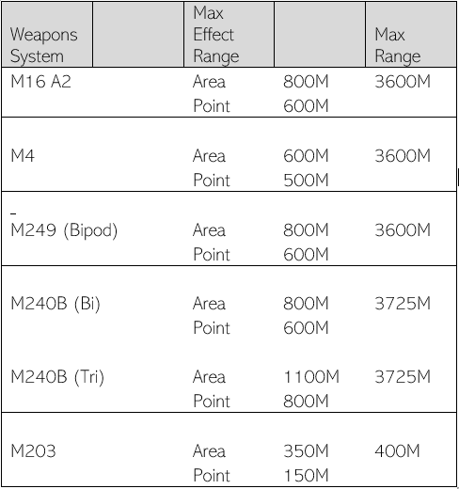
Activity
Location
Uniform
Time
Equipment

Going
Others going
Time gone
What to do if leader doesn’t return
Actions taken if receive contact

Liquid
Ammunition
Casualties
Equipment
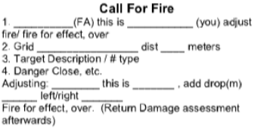

Weapons Ranges

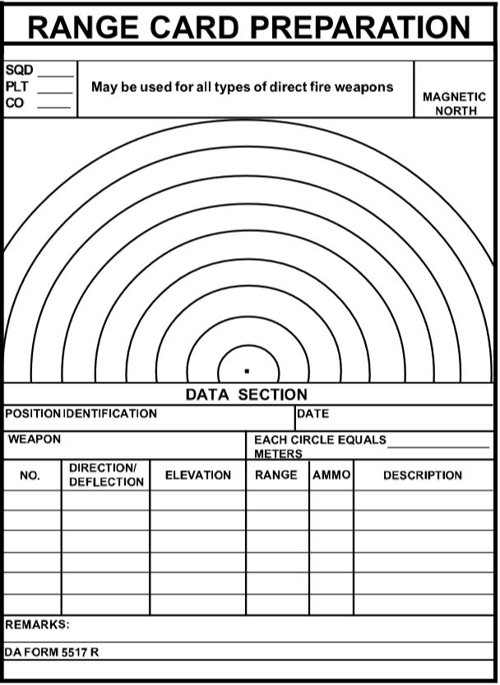 Sensitive Items Tracker
Name/position  Smith/A TL | Weapon  M4A1 | SN  W00357 | Other Items  Radio (33476)
Notes/Additional Equipment:

